November 2017
restart and restart autotest, a new safety concept
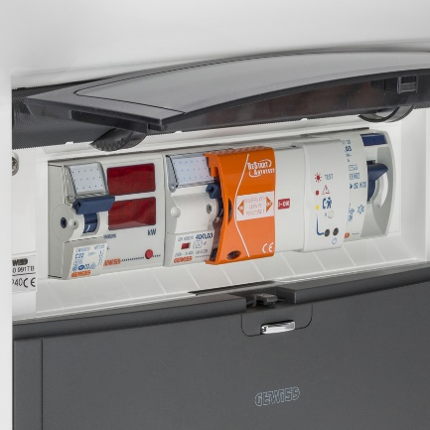
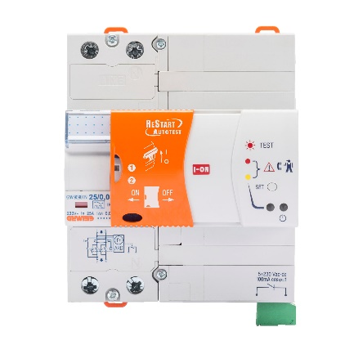
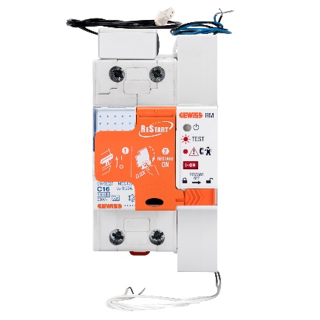
GEWISS presents the new version of the protection devices that guarantee total safety for people whilst ensuring continuous system efficiency. A universal system that is suitable for use in any application context.
Developing and producing electrotechnical products means giving shape to the concept of safety first and foremost, placing it at the heart of the company's development plan, ahead of any other business goal. And GEWISS is acutely aware of this. Indeed, this knowledge has led to the creation of the new ReStart family, a range of advanced residual current devices that guarantee total safety in every context. In order to achieve absolute safety, this concept must be at the heart of every type of system, whether residential, industrial or domestic, protecting both people and things. But above all, safety must combine seamlessly with service continuity.
The new concept of safety as imagined by GEWISS assumes a dual form: with ReStart solutions, which ensure service continuity in case of untimely tripping, only resetting the residual current circuit breaker once it has ensured that there are no faults in the system; with ReStart Autotest solutions, which offer the ultimate in safety, regularly performing automatic tests on the residual current device without cutting power to the system.
ReStart and ReStart Autotest are also ideal for unsupervised systems, ensuring service continuity and reducing maintenance-related issues.
The exclusive benefits of ReStart
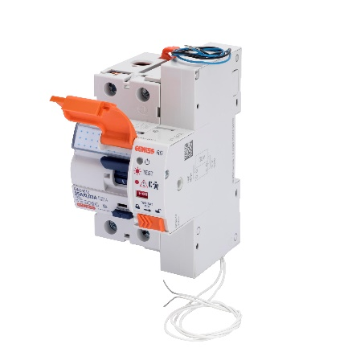
ReStart ensures that the system is automatically reset in case of untimely tripping of the circuit breaker, preventing disruption and possible damage within any environment (residential, domestic and industrial). ReStart devices only restore power to the system once they have checked it for faults. This ensures total safety of both people and things, eliminating any risk of electric shock.
Furthermore, the new version of the ReStart device is even more compact: the solution for single-phase systems only occupies one DIN module, for the widest possible options for installation within the enclosure.
In addition, ReStart is now even faster: all versions can check the system and reset the circuit breaker in just 10 seconds.
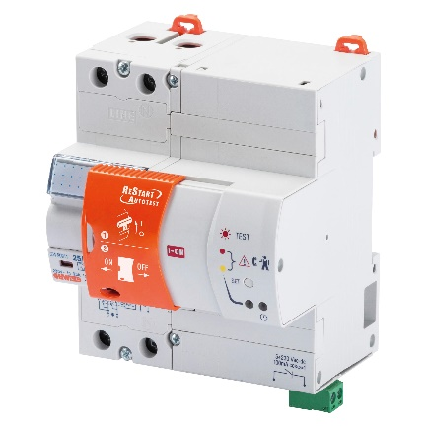
The exclusive benefits of ReStart Autotest
ReStart Autotest is the only device on the market that can carry out periodic safety testing on the residual current, without cutting power to the system. This function is enabled by GEWISS' special patented bypass contacts. This eliminates any disadvantages relating to interruptions in the power supply or voltage dips.
ReStart Autotest performs a test every 28 days, guaranteeing ultimate safety for the user and total efficiency for the protection device. This guarantees maximum residual current protection efficiency, even over a very long period of time.
Finally, ReStart Autotest is available in 2P and 4P versions for single-phase and three-phase distribution systems, for maximum safety in any application context.
Both the ReStart and ReStart Autotest devices are available in PRO and TOP versions.
The PRO versions of the ReStart and ReStart Autotest offer continuous control and protection of the system. When the circuit breaker trips, these devices check the state of insulation of the system for as long as it takes until the fault has been resolved, before resetting the system in total safety.
The TOP versions, meanwhile, are ideal for domestic and industrial applications. They enable the timing and modes according to which the circuit breaker is automatically reset to be adjusted, so the operator can set the number of attempts and the automatic reset time delay.
The advanced features of the ReStart make it suitable for use in a range of different installations, in the residential, domestic and industrial sectors and in "special" applications. Reliability and service continuity are also guaranteed for systems installed in remote locations, with no need for expensive technical operations to resolve false alarms, or where a temporary black-out occurs.
Continuous safety. This is the safety concept proposed by the ReStart family of solutions. And all of this translates into a better quality of life. Anywhere.

