November 2017
A NEW AGE FOR PROTECTION
The GEWISS 90 MCB modular circuit breaker range offers complete electrical circuit protection for domestic, commercial and industrial applications.
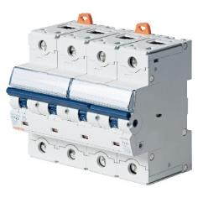
The GEWISS 90 MCB range is a complete line of modular circuit breakers for the protection of electrical circuits, which can meet any overcurrent and short circuit protection requirements in all domestic, commercial and industrial applications. An extensive choice of products is available, with a wide range of breaking capacities (up to 25 kA, as per EN 60898), calibrations (up to 125 A) and characteristics (B, C and D).
The range is made up of three types of products:
- Compact miniature circuit breakers (MTCs): From 2 to 32A in B and C characteristics, with a breaking capacity of up to 10kA
- Traditional miniature circuit breakers (MT): From 1 to 63A in B, C and C characteristics, with a breaking capacity of up to 25kA
- High-power miniature circuit breaker (MTHP): From 20 to 125A in C and D characteristics, with a breaking capacity of up to 25kA.
The compact versions (MTCs) ensure 2-pole protection for each module: this enables a significant reduction in space to be achieved (up to 50%) in terms of occupied modules, which allows for smaller boards to be created, and can lead to reduced costs. Compact solutions are particularly recommended for contexts where limited space is a key factor. This is the case, for example, with many renovation projects, especially in buildings of particular artistic value, where boards and enclosures must be as invisible as possible, or in the naval field, where there is a chronic lack of space.
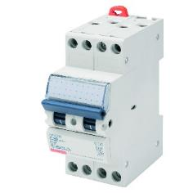
The modular circuit breakers from the 90 MCB range ensure maximum safety: The terminals are equipped with a protective sliding isolating insert that ensures secure, fully-protected tightening against any contacts with live components. Furthermore, the complete integration between the circuit breakers and all electrical auxiliaries in the 90 range allow accessory management to be simplified and rationalised. Finally, the entire range shares common design features, for a pleasant aesthetic and functional coordination between the various elements.

