November 2016
SETTING OUR SIGHTS ON THE SUN
Just a few months after approval of the latest feed-in tariff, GEWISS is supplying products for photovoltaic systems, as a player in the surprising growth trend of renewable energies over the last few years.
Today, photovoltaics is still an investment choice, not only for ecological reasons, but also for cutting energy requirement costs. With government benefits, everyone can produce electricity and this is why photovoltaics, unlike other renewable energies, has involved not only the industrial sphere but above all the commercial and residential sectors, calling for specific products for the development of plants and systems.
GEWISS has designed solutions to transport the energy produced by photovoltaic panels until it is put onto the low voltage grid. Its equipment covers both DC and AC side requirements, meeting the most wide-ranging needs for system protection, isolation, distribution and trunking.
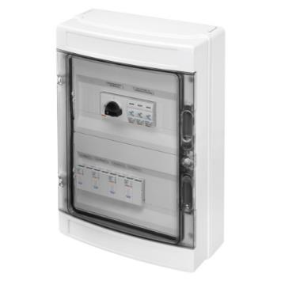
Prewired string boards
The string boards have been designed for installation in photovoltaic systems with a capacity up to 1000V DC. With an insulation class II rating, the boards have all components necessary for system isolation and protection, as well as cable glands and terminal blocks for quick, safe and easy connection to the system. The cable glands are supplied loose, for customised cable inlets (from the top, bottom or sides). The terminal blocks, including earthing connection blocks, are equipotential.
Modular DC devices
- Compact rotary switch disconnectors (only 3.5 modules) allow for DC side disconnection. These are available in two-pole and four-pole versions up to 1000V and guarantee the best performance, also for DC22B utilisation category.
- Dedicated, specific surge protection limiters for photovoltaics provide total protection from indirect discharges (Type 2). All versions have removable cartridges, with an end-of-life indicator.
- Fuse-holder bases and fuses protect and isolate the individual strings, for better electricity production management and back-up protection for the surge protection limiters.
Self-reclosing devices
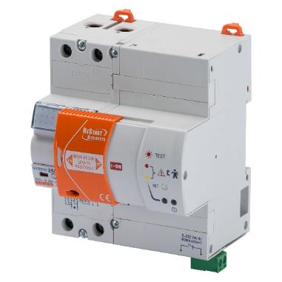
The earth leakages of the inverter, along with sudden voltage surges and lightning, can generate the untimely tripping of the residual current protection, with a consequential loss of electricity production. Today, these losses can be prevented, by combining residual current protection with the automatic ReStart reset device. In the case of untimely tripping, ReStart safely resets the associated switch, guaranteeing maximum operating continuity for the photovoltaic system and maximum yield for the electricity produced. If the system suffers a permanent fault, a built-in auxiliary contact sends a remote signal with the information, so you can intervene quickly. Plus the innovative ReStart RM TOP reset device can set the insulation threshold (from 30 to 500mA), and procedures and times for automatic resetting based on user needs and plant requirements.
AC side protection
GEWISS products for AC side protection can meet all system requirements in the residential, commercial and industrial sectors, with an extensive product range, from modular devices to moulded-case circuit breakers, modular accessories and distribution boards.
Modular AC devices
- LST surge protection limiters, suitable for AC side protection from overvoltage generated by atmospheric discharges, for maximum inverter service continuity. The limiters are also available in versions with integrated auxiliary contact, to remotely indicate the end of life of removable cartridges.
- Type B residual current circuit breakers, for protection from AC side indirect contacts, in situations where inverters without transformers are installed or the inverter is constructed in such a way as to prevent direct current dispersion to earth due to faults.
Moulded-case circuit breakers and metal distribution boards
The selection of MTX moulded-case circuit breakers and the 47 CVX range are the ideal solution for protecting the AC side of large photovoltaic systems. The CVX metal distribution boards for indoor environments can be completed with the MTX circuit breakers which offer notable potential in terms of calibration and breaking capacity, thereby meeting every installation need.
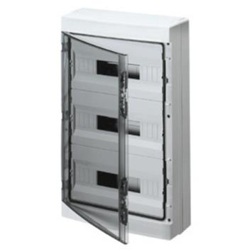
Empty, string or parallel enclosures and modular boards
The range comprises 40CDK_IP65 enclosures and boards in 4 to 72 module versions, for countless configurations and for protection and parallel solutions in small and large-scale photovoltaic systems in the industrial, commercial and residential sectors. The operating voltage (Ui), equal to 1000V DC, enables latest-generation, high performance inverters to be used in the field, to maximise photovoltaic system productivity. The excellent IK09 impact resistance, the IP65 degree of protection and configuration for safety locks and leadable panels ensure professional installation and the utmost safety for operating continuity. The enclosures and boards are also available as prewired versions.
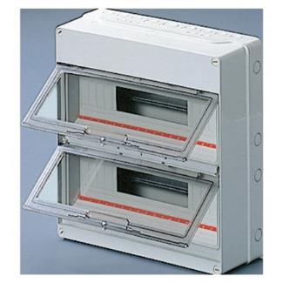
Empty, compact string or parallel enclosures
The range comprises 40CD_IP55 type 4 to 36 module enclosures, for numerous AC and DC side board configurations. The compact size is ideal for use in small areas such as niches, compartments and eaves which are typical of the commercial and residential sector, where small- and medium-scale photovoltaic systems are common. The reliability of the application is guaranteed by a watertight system with IP55 degree of protection and excellent IK09 impact resistance. Tested for an operating voltage (Ui) up to 1000V DC, the enclosures can also be used for DC side boards in photovoltaic systems with high energy-production inverters. The enclosures are also suitable for small, cost-effective parallel boards.
Empty junction and control boxes
A wide range of 44CE boxes in 3 different materials for an outstanding performance and customised solutions. The boxes feature an IP56 degree of protection and are available with a standard or high-capacity back-mounting box (a new feature), and high or low blank or see-through covers, and smooth sides. Tested for photovoltaic applications, (a 190 x 140 mm size), the boxes are ideal as junction boxes or to house electronic boards for alarm or system control and energy management.
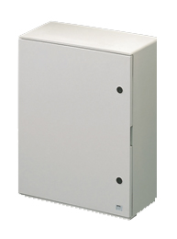
Empty polyester string or parallel boards
The 46QP range of boards comprises seven sizes and offers the possibility to install up to 180 modules. The boards are available in blank or transparent door versions. The excellent IP65 degree of protection, and halogen-free, glass fiber enriched polyester makes the boards ideal for outdoor use. The considerable Ui insulating voltage = 1000V enables use as string or parallel boards in large-scale commercial and industrial systems and for photovoltaic field installations. Specific pole support kits enable the boards to be positioned at the centre of gravity points of the photovoltaic system, while
safety locks ensure access for specialist personnel only.
Cable trays for field cables
A complete system for metal wire cable trays, punched sheet metal plate cable trays and bracket systems, ideal for commercial and industrial photovoltaic applications: the wide range of sizes, capacities and surface finishes means you can choose the most suitable product for every requirement, from small installations to large industrial systems.

The BFR wire cable tray with new HP finish
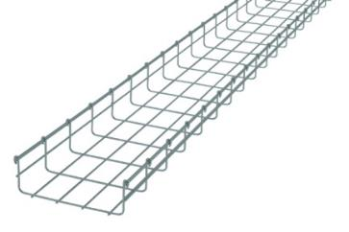
GEWISS has designed an exclusive innovative surface treatment for wire cable trays, called HP (High Protection). The wire is protected by combining zinc and aluminium, to give the metal dual active protection (zinc acts as the sacrificial anode oxidising before aluminium) and passive protection (the aluminium oxide creates a protective film which is highly resistant against corrosion).

