November 2016
OVERVOLTAGE - UNDER CONTROL
The new family of LST surge protection limiters stands out with its wide range of products and new performance.
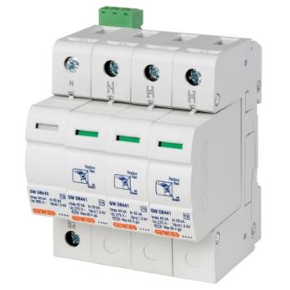
Overvoltage of an atmospheric origin is the main cause of failure in electronic equipment and of production downtimes. The most hazardous type of overvoltage is caused by direct lightning strikes: In fact, lightning creates current peaks that generate electricity and data transmission network overvoltages, the effects of which can be extremely harmful and dangerous for systems, structures and people. GEWISS has a new family of LST surge protection limiters to guarantee the protection of the whole electrical system and avoid damage to even the most sensitive equipment.
The new family of surge protection limiters embraces a modern technological solution, with type 2 SPLs combined with type 1+2 SPLs for photovoltaics. In particular, the combined LST range (type 1+2) ensures electrical circuit protection from direct and indirect lightning strikes in a single device.
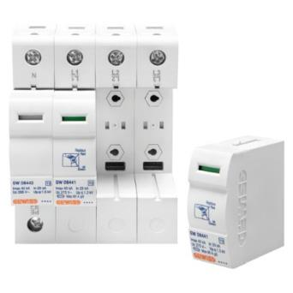
The LSTs have been designed to readily identify the status of protection device operation and make maintenance easier. The optical indicator on the front changes from green to red to show that the device has reached the end of its lifespan. Thanks to the integrated auxiliary contact, it is possible to immediately report the inefficiency of the protective device. The removable cartridges make replacement easier and quicker, and prevent wiring errors.
The new LST range perfectly complements other GEWISS protection devices, and features a similar design and style content. Plus the guarantee of a reliable, effective product, its design, development and process control are all based on the highest international quality standards.
In regulatory terms, the LST range complies with new requirements of CEI 64-8/3. The standard, which came into force in September 2011, recommends, for performance and usability levels 1 and 2, an “SPD at the end of the line if necessary to make risk 1”tolerable, while for level 3, it is mandatory to have an “SPD in the system in order to protect against pulsed overvoltages, in addition to that specified for levels 1 and 2”. Therefore, by selecting a suitable surge protection limiter belonging to the LST range, it is possible to keep up with the new installation regulations and prevent damage to people and to electronic equipment.

