November 2017

UESSE SARNICO 1908: WHERE TALENT IS GROWN

An 85% reduction in energy consumption, with improved lighting quality on the pitch: UESSE Sarnico 1908 turns to the Football Innovation experts to modernise its facilities.

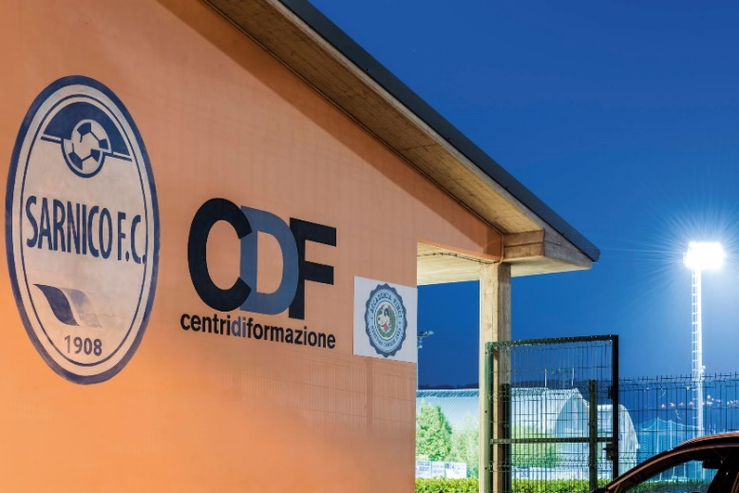What do the leading champions of the Serie A football league - the likes of Donnarumma, Buffon, Bonucci, Candreva, Bernardeschi, Insigne, Immobile and Belotti - have in common with the players in amateur teams? Each and every one of them have cut their teeth on local pitches before joining their current clubs, kicking a ball around from a very early age. Youth sectors and amateur football associations constitute the hidden element of the "Italian Football Movement", an iceberg whose tip is visible for all to see, represented by the glorious champions of Italian national team. As far as we can observe, from the third division to the top of the league, Italian football is a single unit, despite the individual characteristics, values and numbers of each player.

But as a matter of fact, behind every great champion are a series of amateur associations that have always been the fertile ground on which Italy's greatest football talents are grown. This is precisely why the Football Innovation project is an important resource for Italian football. The initiative, launched by GEWISS in collaboration with the Lega Nazionale Dilettanti (LND, or National Amateur League in English) and in partnership with CORUS, is dedicated to the modernisation of Italian sports facilities, from pitch lighting to the stands and changing rooms. These measures help to improve the conditions in these facilities, enabling more than a million athletes to express their technical skills to the best of their ability. And, as a result, the entire Italian football movement continues to grow.

UESSE Sarnico 1908, an association that represents a beacon for the youth sectors and amateur leagues across the entire province of Bergamo, has also signed up for the project.

"*The first important step*," explains **Michele PARIS**, Chairman of UESSE Sarnico 1908, "*was to fit the new synthetic pitch*. ***This significant investment was supported by the Municipality****, which has enabled us to continue to evolve and improve our partnership with the Inter Training Centre. Resurfacing the pitch has enabled us to focus all of our activities within the sports centre. These activities usually take place in the afternoons and evenings, and accordingly, given that the previous* ***lighting system, which was installed in the eighties, consumed large amounts of energy and required extensive maintenance****, we contacted the Football Innovation team of experts, in agreement with the Municipality. Today, we use the* ***new GEWISS LED devices to light our facility - they have enabled us to reduce energy consumption, running costs and maintenance****. Our decision to make this investment was motivated by our goal to host 28 teams at the centre within three years. We currently have 23: our selection teams, consisting of children selected from the youth sectors of other sports associations, are now also accompanied by local educational-play 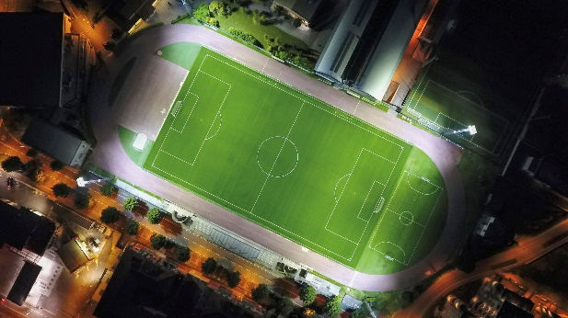activities - the spaces and structure we now have enable us to offer this, with the Accademia Vinci for the 6-12 age groups. We also work with the academy in nurseries and primary schools, enlisting the help of experts in psychomotility. In addition, as of this year, the facility is now an Inter training centre for female players, with the 2007 and 2008 teams. Sarnico has always been recognised as a point of reference for the youth sector, but our journey has now taken us to the next level, thanks to our partnership with Inter and our newly upgraded sports facility*".

"*We launched the Sarnico pilot project*," explains **Bruno CASIRAGHI**, Technical Director of the **Inter Training Centre**, "*in 2009. The quality of work and the continuity of the activities organised as part of the project are rooted in the foundations and working philosophy that the Inter Training Centre and Uesse Sarnico share. Our goal is to relocate the projects scattered through the various Italian provinces to Interello, the headquarters of the Inter youth sector.* ***The results we have achieved are extremely satisfactory****: over the course of the last few years, more than 40 Uesse Sarnico players have joined Inter's youth sector, despite the fact that we are located at the crossroads of an Atalanta, Brescia, and Cremona F.C. enclave. The young people are delighted to come to Sarnico, because the association chooses coaches who have the right qualities to teach them, and the right characteristics to relate to both children and parents at a human level. For us, working with people who believe and* ***invest heavily in systems, logistics and staff is a guarantee of quality***."

Despite the fact that the Uesse Sarnico facility proved to be a complex structure, the Football Innovation team succeeded in proposing a design solution that meets the LND standards. The luminaires are fitted at a height of 30 metres from the ground, on the lighting towers at each corner of the pitch, behind the athletics track that runs around the outside of the field.

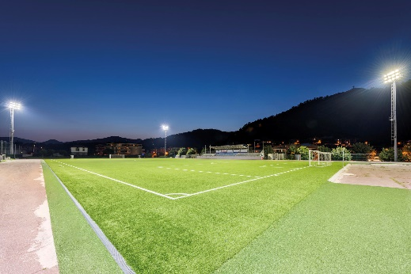*"Providing the right amount of light in the midfield, which is located more than 80 metres from the light sources, called for a careful analysis of the design,*" says **Davide BONALUMI**, CEO of Corus and business partner to GEWISS under the Football Innovation project, " *but this was a success, and has led to significant improvements in the lighting conditions, and has* ***cut energy consumption by 85%****.* *Thirteen 340 Watt GEWISS Smart[Pro] LED devices with two modules were installed on each lighting tower, a major change from the twelve 2,000 Watt floodlights installed previously: energy consumption has been reduced from 52.8 KW per year to 8.9 KW, slashing the total bill from 13,000 Euros to just over 2,100 Euros*, ***with a return on investment after just 24 months****. Overall****, the result is a significant improvement in lighting on the pitch*** *with an average of more than 100 lux on the ground and a degree of uniformity that far exceeds the parameters set by the applicable regulations. Another unique feature of the Sarnico system* ***is that it enables the lightning towers to be switched on remotely via a remote control****: unlike traditional solutions, GEWISS LED devices do not require lamp heating or cooling time, and therefore can be switched on or off as desired. Furthermore*, ***each tower can be switched on separately from the others***, *so that only the areas of the pitch being used for training need to be lit.*"

All in all, **experience, organisation, skill and efficient infrastructures** are the key ingredients of the "recipe" chosen by Uesse Sarnico 1908 to cultivate the talent of future generations. And to nurture the champions of tomorrow.