November 2017

SMART[3], ELEGANce, EFFICIENce, VERSATILity and Safety

GEWISS presents SMART[3], the new watertight LED luminaires range subdivided in three versions: Smart[3], Smart[3] S e Smart[3] C.

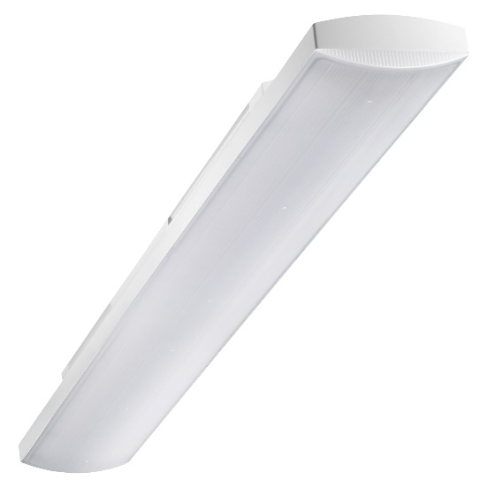The new Smart [3] devices are a GEWISS patent. They're entirely designed, developed and produced in Italy. They are distinguished by an elegant design that highlights the particular features of the new LED technology, their extremely reduced energy consumption, their high impact resistance and their quick, easy installation. Smart[3] has been developed to become **the first LED lighting solution in the world with exceptionally high protection of IP69**.

The design and geometries of these new luminaires are purposely conceived for **the compact dimensions of lamps** **using the latest technology**, adding a touch of elegance and lightness in every application context. What's more, Smart [3] allows a **reduction in energy consumption of up to 50%** compared with a luminaire that uses a traditional lamp (T8). To save while lighting, and to light while ensuring the best visual comfort.

The opal or transparent shield with longitudinal faceting makes Smart [3] the ideal solution not only in industrial contexts but wherever the **maximum attention to visual comfort** is called for. The body is made entirely of polycarbonate, so the device can be installed in food-related environments too (HACCP, BRC, IFS directives). Ideal for areas with a high degree of humidity or a high concentration of dust, Smart [3] can even be installed in car parks and garages, outdoor areas underneath roof shelters, warehouses, circulation areas, storage areas, supermarkets, railway stations, bus terminals and shopping centres.

The choice of materials and the design logic of these new luminaires guarantee optimum safety during use and **excellent resistance** to impact, accidental knocks, water jets, humidity, foreign bodies and dust.

**SMART[3] – A NEW CONCEPT IN LED LIGHTING.** The new Smart [3] LED watertight luminaires boast excellent technical performance and extremely compact design. Made entirely of polycarbonate, they're ideal in installation contexts with a height of less than 4 metres. They stand out on the market for their higher degree of protection against the penetration of dust or liquid (IP69), not to mention optimum impact resistance (level IK08). The three sizes available - 800mm, 1200mm and 1600mm - make these GEWISS luminaires ideal for relamping in various types of context. Lastly, the versions of Smart [3] equipped with the DALI dimming function are especially suitable for energy consumption control. The versions with stand-alone feed-through wiring can be fitted with an emergency KIT (3-hour duration).

**SMART[3] S – ONE SIZE, MAXIMUM POWER.** Smart [3] S is a high-power LED luminaire (67W) that comes in one single size - 1600mm - with a light emission level of more than 8000lm. Versatile and innovative, when installed in new systems it's the ideal solution for energy efficiency as it notably reduces the number of luminaires required, compared with the versions using traditional technology. In existing systems, it's highly valued for its easy installation; in fact, the variable fixing centre distance means there's no need for interventions on the electrical system.

**SMART[3] C – COMPACT SIZE, LOW CONSUMPTION.** Smart [3] C is a “compact” model, guaranteeing excellent energy efficiency levels in the 800mm version in particular: reduced power (35W) but high lumen output (over 4000lm). For lighting efficiency that reaches 116 lm/W in the version with transparent shield. This GEWISS devices is designed to optimise efficiency in terms of lm/W, and offer lighting packages that guarantee top results. The 800mm versions of Smart [3] C are the perfect solution when replacing 2x36W watertight luminaires that use traditional technology, whereas the 1200mm versions can replace the traditional 2x58W models. Always with the support of innovative LED technology.