November 2017

A r-evolution in mobility

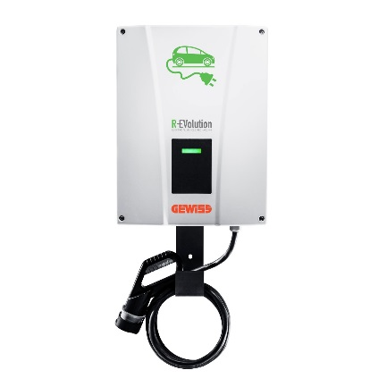GEWISS is making tracks towards Smart Mobility with the launch of R-EVolution and R-EVolution EASY, the new range of electric vehicle charging units.

"Smart Mobility" is soon to become a major feature in all of our lives, definitively changing the way we move and imagine cars forever. A real revolution. Within this changing context, GEWISS has launched **R-EVolution** and **R-EVolution EASY**, the new range of boards and outlet boxes for **charging** all **electrical** vehicles. The range of products available guarantees a safe, reliable solution suited to the current charging requirements for all types of vehicles, in line with **EN 61851** regulations.

There are four **R-EVolution** models available - ***Home***, ***Parking***, ***Parking+*** and ***Station*** *–* and these can be set up both in residential (private) and public spaces.

**Private** charging points can be installed in individual homes or apartment buildings with parking spaces, and are particularly suitable for **extended periods of parking and recharging** - for example overnight. The nominal power of these charging points ranges from **4.6 kW** to **7.4 kW**, covering the average daily distances travelled by most cars.

Meanwhile, **public** spaces include all installations where access to the charging point is not limited to just a few individuals, but rather is available for use by anyone who wishes to charge their vehicle. Often, the charging period for vehicles **parked** in these spaces is **short-medium**, and as such, the nominal power of the outlet boxes in these locations can be anything up **to 22 kW**, enabling a full vehicle charge to be completed in an hour or a little more. In structural terms, the charging solutions installed in public spaces are similar to those that offer less power. They use the same type of socket-outlet, and are compatible with vehicles that are usually charged at lower power levels.

The **R-EVolution EASY** range has been designed for basic applications and needs, where simple EV charging functions are required. Made from green thermoplastic material, all versions of the EASY are also resistant to UV rays, in line with EN 62208.

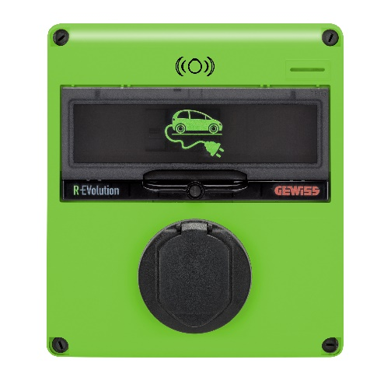The R-Evolution EASY range is composed of three different models: ***Easy Home*** are MODE 2 and MODE 3 surface-mounting columns, available either with a mobile charging connector or with a Type 2 fixed socket-outlet; ***Easy Parking*** are MODE 3 surface-mounting charging stations fitted with Type 2 fixed socket-outlet chargers, ranging from 7.4 kW to 22 kW, enabling any vehicle to be charged in just over an hour; ***QMC E-bike*** solutions are suitable for charging all types of electric bicycle;

Thanks to the wide range of services offered, GEWISS is an **international player** in the production of advanced, secure and reliable electrical systems. The company's philosophy is based on the principle of "development as a constant feature of management", a 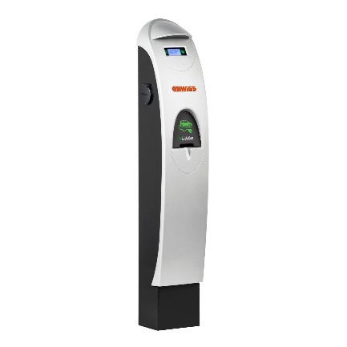vocation that also translates into the ability to imagine the **future**. A future that today, in the field of mobility, surely lies in **electricity**.

This is precisely why GEWISS considers **electric cars** to be the best new means of getting around, combining individual requirements with the global need to safeguard our **environment** and the resources available to us. For a more functional and **environmentally-friendly** approach to developments in mobility. Or in other words - a **Smart** approach.