November 2017

CHORUS, THE BEAUTY OF RESTORATION

The GEWISS international domotic system has been chosen for the restoration of an ancient, noble farmhouse in the Lombardy region.

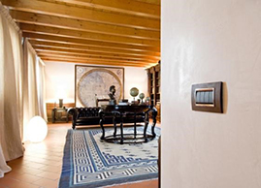CHORUS is a system that offers state-of-the-art solutions for house and building control and management, and features various cutting-edge new technologies. A device which improves quality of life within the home. Since its launch, CHORUS has been used in a host of applications, courtesy of the advantages it offers from the perspective of safety, comfort, energy savings and design.

This international domotic system combines the most advanced domestic technologies with unmistakable Italian design flair, characterising each component and enhancing the "personality" of the environments in which it is installed; furthermore, Chorus enables intelligent management of all domestic functions, which can be automated and integrated in order to achieve maximum safety and comfort in the home.

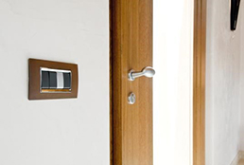Indeed, Chorus allows users to create multi-zonal climate configurations and to set different temperatures in the various rooms or floors of a house; the use of compact residual current circuit breakers with overcurrent protection also allows for significant space savings (up to 50%) and the system configurations can be selected in accordance with individual requirements. The wide range of CHORUS products provides a host of solutions which can be adapted to customer requirements and resources.

For the above reasons, this innovative GEWISS Home & Building Automation system can be seamlessly installed in any context, from residential environments to the commercial sector: villas, apartments, resorts, public buildings, offices - when it comes to the intelligent management of systems, there are no limits. Indeed, many installers and electrical system designers have chosen CHORUS domotics to create systems in environments such as farmhouses, hotels and luxury residences.

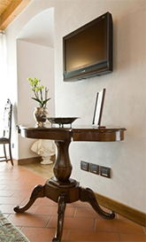Decorations, friezes, furnishings: every detail that makes up the splendid architecture of the old farmhouse in the province of Bergamo, on the slopes of the Orobie Alps, recalls the wisdom and mastery of craftsmanship, and the value of "handmade", artisan products. This ancient restored farmhouse is now a cosy nest, where every tiny detail is designed to confer a sense of familiarity and intimacy upon each space. Without compromising on comfort or convenience.

“When I saw the new CHORUS system”, explains Livio Gavazzi, owner of Elettrica LG, “I was immediately struck by its design. As a result, I was the one who proposed this solution, and I must say that my customer was also extremely impressed by the beauty of the plates. In this instance, we chose the LUX plate in oxidised iron, because of the way it complements the different environments within this beautiful farmhouse." The customer also chose an original finish for the button keys. "The black buttons were combined with a titanium finish, in order to make it easier to identify certain commands immediately."

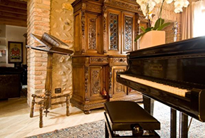The system in this residential building has been automated using CHORUS domotics solutions. "By adopting CHORUS," adds Gavazzi, "we succeeded in meeting all of the requirements expressed by our customer. As a matter of fact, we were able to manage the automation of both the windows and the dormers, as well as installing a remote operation system for signals from the boiler. Moreover, the opening of the gate and the bascules can be controlled from any room in the house. In addition, we could also use the system to interface with the burglar alarm. Thanks to the actuators, when the alarm is tripped, the external perimeter lights switch on, and an automatic telephone call is made to the security company. Given the size of the building, we decided to use the CHORUS domotics for two reasons. First of all, it enabled us to work more easily, despite the large distances present, with no need to use long sections of wires, commands and returns; indeed, courtesy of the BUS technology, the commands can be placed wherever the user prefers. Finally, the KNX communication protocol is an open standard format, and as such, enables integration with other devices and systems as well."

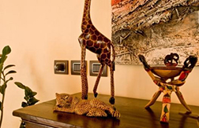Climate control and energy management devices were also installed inside the farmhouse. "CHORUS offers a full range of products. In addition to four-pole, three-phase miniature circuit breakers, we also installed residual current circuit breakers with overcurrent protection to ensure safety in all rooms. Finally, we were also able to use CHORUS thermostats, which, when placed in every space and room, enable intelligent temperature management within the home."

"In short," Gavazzi explains in conclusion, "I can confirm that I am very impressed by CHORUS, and the customer was also very satisfied. And not just from an aesthetic point of view - choosing CHORUS domotics enables quick, efficient operation with no time wasted, even when you want to change a number of commands."