THE QUALITY THINKING OF PRIMA INDUSTRIES MEETS THE QUALITY OF SMART [4] TECHNOLOGY BY GEWISS

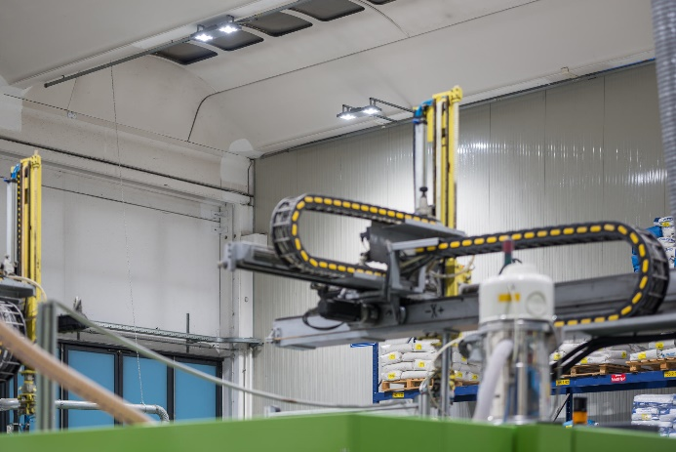***The new GEWISS lighting system provides efficiency, visual comfort and sustainability for the company based in Emilia-Romagna, leading to savings of 2000h/year in terms of use of luminaires.***

Green technology illuminates the production department and warehouse area at **PRIMA Industries**, an Italian company with three divisions dedicated to the production of components for industrial vehicles, for labelling/bottling applications and for the lighting industry. Indeed, the company, which is renowned worldwide for the levels of quality, reliability and professionalism it provides to customers, has chosen **Gewiss Smart [4**] technology in order to improve the **energy efficiency** of lighting systems in its production department and warehouse.

Every activity that takes place at PRIMA Industries can be traced back to "**Quality thinking**", the company philosophy that encapsulates the fundamental principles of perfection. In over twenty years of experience, PRIMA Industries has worked tirelessly to satisfy the needs of its customers, and is always on the look-out for **high-quality, integrated production systems**. All of the divisions of PRIMA Industries are engaged in a shared quest to identify new solutions and to look for new structures and services in line with market trends and customer requirements. **Technology** is one of the fundamental requirements for ensuring guaranteed quality. In line with this philosophy, the company has decided to replace the now-obsolete old-generation lighting system in its production and warehouse areas. After a careful analysis of the LED technologies available on the market, and guided by its expertise in the lighting sector, the company turned to Gewiss Smart [4] solutions, due to the fact that these meet the standards of quality and efficiency for which the company is recognised globally.

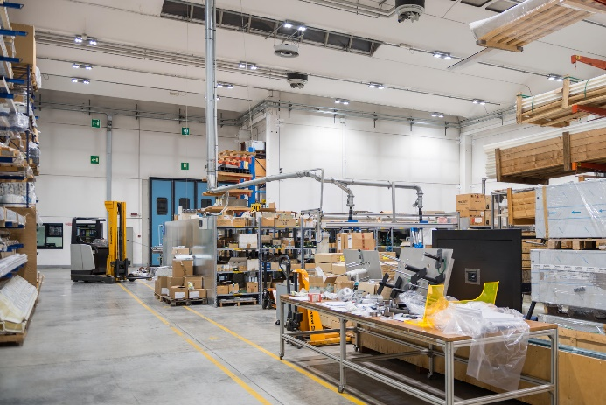In contrast to the previous lighting solutions, the **86 Smart [4] devices** installed at the facility were able to meet the three fundamental requirements of the new plant: Energy efficiency, visual comfort and sustainability. Indeed, these new technologies have guaranteed savings across the board (calculated on the basis of an average of 2600 hours of use per year), with a reduction in consumption from 105,092 kWh/year to just 25,938 KWh/year - a **75% decrease** which equates to a saving of 79,154 KWh/year, equivalent to 15 tonnes of oil and 43 tonnes of CO2 not emitted into the atmosphere. In addition, the extreme ease of installation of the Smart [4] system allowed the company to replace the existing devices in just 7 days.

**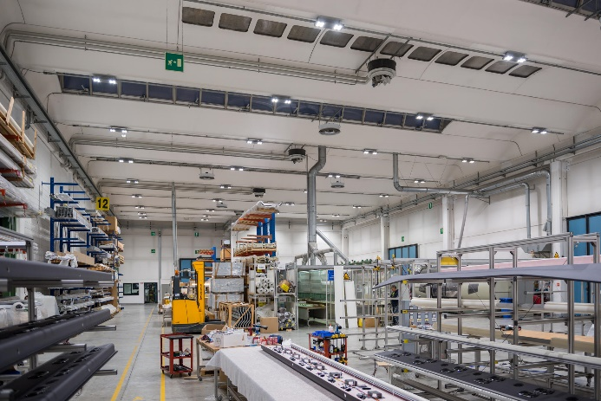*Marco Accorsi, head of the Prima Industries plant****, commented: "We are delighted to have chosen Gewiss quality, and this has received very positive immediate feedback from our employees, both from the point of view of comfort and with regard to general well-being and professional performance.* ***The absence of chromatic dominance and dark spots*** *has also brought about a visible improvement in the quality of work and in the physical and psychological health of employees."*

***Aldo Bigatti, sales and marketing director for the Gewiss Lighting division, added****: "We are honoured that our Smart [4] technologies have been chosen by Prima Industries, are proud that this project, to which we have devoted a great deal of effort and commitment, is receiving positive and satisfactory feedback from the market. We work to innovate and to foster innovation, and as such, we are thrilled with the results achieved so far."*

**Smart [4]**

The Smart [4] device enables maximum energy savings (from 50-80%) along with the best possible visual comfort. Smart [4] is multiform, rational, sustainable, extremely lightweight and versatile; it can be transformed from a ceiling light/high bay to a floodlight, offering different performance levels for different contexts. The practicality of the device guarantees maximum lighting performance in any area of application, from industrial to sports environments, indoor or outdoor. And that's not all. The horizontal and vertical modularity of this product combines with easy installation and maintenance, the use of “green” construction materials (plastic and aluminium with an extremely low copper content), no environmentally harmful production processes, and easy disassembly at the end of its working life so the parts can be recycled.

Smart [4] is innovative technology enclosed in a minimalist, sharp, linear style with a definite Italian feel. The design aim, in fact, was to emphasise the typical characteristics of LED lamps: lightweight, small, practical and robust. These features were transferred to the end product, providing it with unequalled performance levels. The use of power LEDs with high colour performance, high efficiency optical systems (high bays and lenses) and the availability of multiple configurations make Smart [4] the ideal tool for minimising costs (for operation and maintenance) and maximising lighting performance, whilst ensuring optimum comfort in the work environment.

The Smart [4] system can take six different optics: four with rotational symmetry (100°, 60°, 30°, 10°), one elliptic (60°x120°), and one asymmetric (52°). The luminous flux varies across the range from 2800 to 25,500 lumens (31-285W, losses included). From the mechanical viewpoint, this system can be held in place in a number of ways: in the plate/spring version, the body is installed after the plate has been fixed, pressing slightly to trigger the steel spring; the quick watertight connector is then used to connect the device to the mains supply, without opening the power supply compartment. Smart [4] was designed and developed as a system for making upgrades truly sustainable, so that lighting systems could be adapted in a quick, easy and cost-effective manner.

|  |
| --- |
| ***GEWISS, INNOVATION SINCE 1970***  *Development as a constant feature of management is the philosophy that has consistently guided the decisions made by GEWISS, from its establishment until today.*  *GEWISS was founded more than 40 years ago and, since its first day of operation, each and every action and decision has been led by quality-focused research and a drive to develop exceptional solutions. Over the years, this dedication to innovation has taken shape, in a company model which is based above all on continual investment in Research & Development.*  *Constant experimentation with new materials and technologies, a global vision of the concept of lighting technology and the formalisation of aesthetics which can be traced back to the unmistakable pillars of Italian design - these are the aspects which lie at the very heart of GEWISS lighting solutions. Together, these elements represent the perfect formula, enabling GEWISS to become a global partner in creating lighting systems designed for every room, every space and every location. Indeed, GEWISS products are perfect for indoor and outdoor installations, industrial contexts, commercial buildings (retail outlets, public buildings) and sports facilities, as well as for street and emergency lighting. The GEWISS lighting range includes architectural floodlights, residential/urban decorative devices, aluminium floodlights, street lighting and recessed and modular fittings for surface and ground installation.* |