November 2017
GEWISS SUSTAINABLE LIGHTING FOR CITYLIFE IN MILAN
In Milan, one of most important so-called "green lungs" in the world is illuminated by the Gewiss Urban [03], the environmentally-friendly lighting system which offers extremely high energy savings.
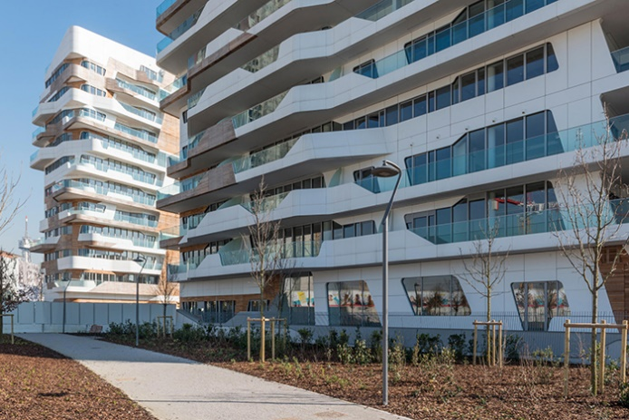
The public park in the CityLife district of Milan is at the heart of this project, and is one of the most important of its kind in the world. A key component of this ecology-focused area, the park spans an area of 168,000 square metres, and along with the Parco Sempione and Giardini Pubblici (public gardens), it represents the third large area of green space in the north-west of Milan.
The City of Milan and the company City Life launched an international competition for the design of the park, which saw the involvement of 70 world-class architectural design studios. The main objective of the project was to transform this space into a prestigious public area for the entire city to enjoy. The park is symbolic, representing a sense of connection, and is deeply integrated with the historic city. Safe and accessible to all, it is a space that fully respects the environment.
The project, which was won by London-based architects Gustafson Porter, saw the creation of a microcosm around the "Tre Torri" (three towers) of the CityLife district, where key features of the landscape of Milan and its surroundings were reproduced. This park, between the mountains and the plains, has succeeded in fully meeting all of the requirements of the customer, including those concerning lighting. Indeed, the architectural design initiative also called for the development of a lighting project to meet a number of the fundamental needs of this venture, in line with the sustainability-focused profile of the CityLife district: the goal of this lighting project was to encourage a sense of physical and psychological safety among inhabitants and visitors to the area, closely connected to the idea that the park can be visited and enjoyed without fear, increasing quality of life and promoting park life even in the evening, whilst guaranteeing high energy savings and ensuring reduced levels of environmental impact.
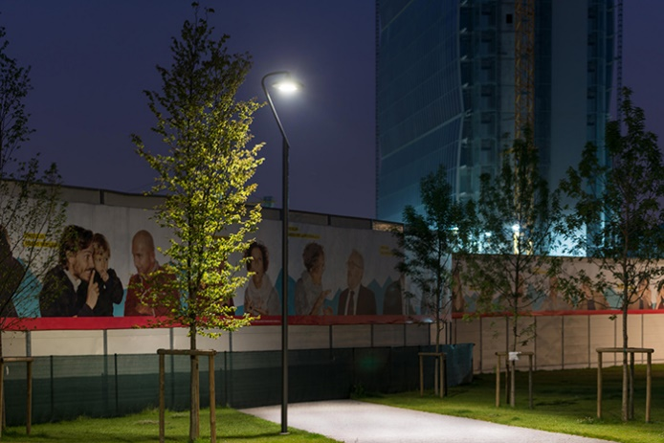
For the implementation of the project, entrusted to the Ferrara Palladino lighting design studio in Milan, the Gewiss URBAN [03] LED lighting system was selected, courtesy of the wide range of fixing accessories and light sources that this line offers, satisfying the many lighting requirements for public and green spaces.
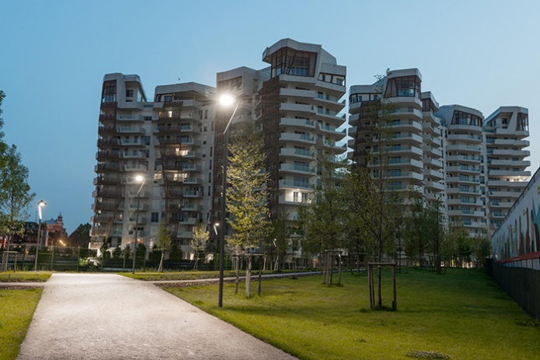
85 URBAN [03] devices were installed along all pedestrian pathways in the park, both in the area reserved for CityLife housing and in the space that is open to the public. Characterised by a simple, pure design, the URBAN [03] lighting integrates seamlessly with the architecture of the park, enhancing its aesthetic appeal. The system, which is equipped with a dual-regime device for regulating the luminous flux during the hours of darkness, enables energy savings of 50%. The URBAN [03] system complies with all requirements in terms of power and resistance to overvoltage surges, with an IP66 degree of protection. Furthermore, the LED light sources have a lifespan of > 50,000 hours, with a 3500K (CRI> 85) colour temperature.

