November 2017

Efficiency and safety in pursuit of imagination  
The hotel at the famous Italian amusement park chooses the efficiency and unmistakable style of GEWISS for its electrical system and walls.

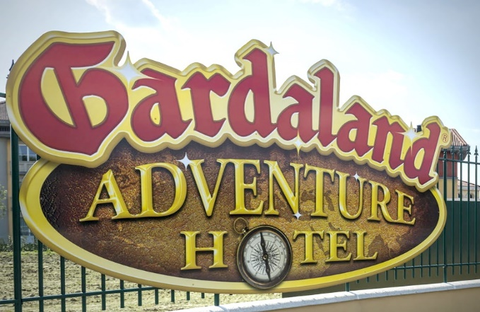Designed to welcome visitors and families who are looking to embark on a unique and unforgettable experience, the Gardaland Adventure Hotel combines the fantastical, dream-like dimension of the adventure with meticulous attention to every detail, with a view to offering superb comfort and personal service to all guests.

“*The concept* (of the hotel, *Ed.*) *is based around a story, a cinematic narrative: a storyboard featuring a hypothetical and somewhat absent-minded traveller who has filled his home with a collection of all of the memorabilia and keepsakes from his travels around the world. The project developed around this travel narrative and vice versa, until the two merged together, blending the real and the imaginary*”. This is the statement made by Luigi Boccuni, the design engineer behind the Gardaland Adventure Hotel project. The result is a habitable architectural object which welcomes guests to this unmistakable "Gardalandian" atmosphere.

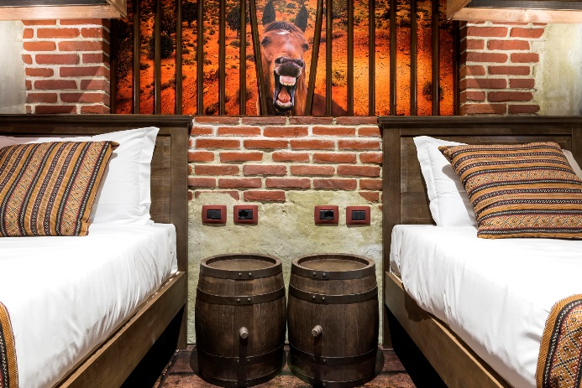This objective has been achieved thanks to the successful collaboration between the various specialised teams involved in the different phases of the project. And of course, thanks to GEWISS plant solutions, which help to provide energy and lighting throughout the structure. Indeed, with more than 20,000 products in the GEWISS catalogue, all designed to integrate seamlessly with one another, the company has succeeded in meeting all of the requirements expressed for the system, guaranteeing high standards both in terms of aesthetics and performance - both crucial elements in the construction of this prestigious complex. *"When choosing solutions for the system*- continues Boccuni - *we have opted for a line which balances technology and simplicity. Indeed, the hotel is designed to welcome families with children, so all the features and services have been designed in order to simplify the interface as far as possible."*

In addition to the enclosures and modular protection devices which ensure the safety of guests in every room, Gardaland Adventure Hotel has also been fitted with industrial plugs and socket-outlets in the technical spaces and kitchens. Safety and functionality are the leading priorities in this instance, accompanied by the unmistakable flair that is typical of Italian design, as expressed by the Chorus domestic range for commanding and controlling both lighting and other key functions. In each room, the plates were chosen in keeping with the dreamy theme that characterises these spaces: the aesthetic flexibility of these plates is a result of the range of shapes and materials in the Chorus series, and is also derived from the possibility to customise the colour of the push-button commands.

The Boccuni studio was involved with all aspects of the project, from the white paper to the creation and implementation of the systems. Each and every one of the various design requirements were met. Boccuni made the following comment on the project: “*Despite its unique nature, this was of the few projects where no particular issues arose - the project time-scales and budget were respected, including the deadlines for the authorisation and approval by the authorities*”.

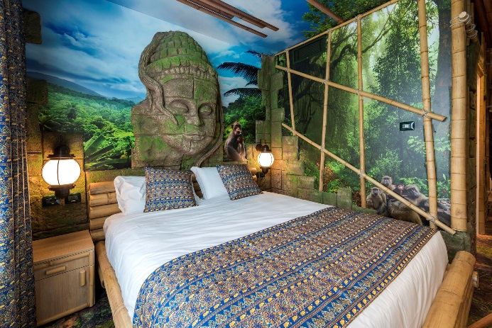Finally, latest-generation LED devices from the Astrid range were selected to light the various walkways and public areas within the structure, offering superb performance and a significant reduction in energy consumption.

*“We chose GEWISS"* explained Luigi Boccuni,*"due to the sheer completeness of the catalogue of products on offer, and on the basis of the reliability and versatility of these products as demonstrated by the technical sales staff. In addition, these expert staff also offered their assistance in customising the colours of the push-button commands to suit any environment. In addition to the Chorus domestic range, the hotel is also equipped with enclosures, circuit breakers, boards and power distribution cabinets, as well as indoor and outdoor lighting systems.* *The aesthetic and functional integration of all products is another aspect that drove us to choose GEWISS."*