November 2017

GEWISS PROVIDES LIGHTING FOR YOKOHAMA ITALIA SPA

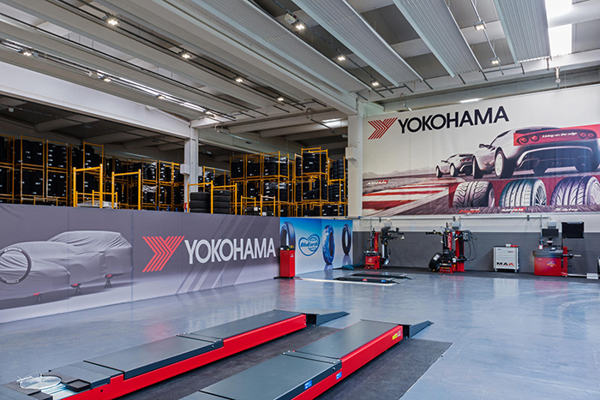A total of 500 Gewiss appliances illuminate the **Yokohama Italia** headquarters in Brescia with "green" lighting solutions. Indeed, from now on, the logistics centre will continue to shine with the most efficient and sustainable **Smart [4] LED light**.

Established in 1990 as a joint venture between Yokohama Tokyo, Marubeni Corporation and Magri Gomme, Yokohama Italia, the Italian subsidiary of the **leading Japanese tyre production company**, operates exclusively through the specialist tyre retail channel.

**Sustainability** has always been one of the pillars upon which the policy of this international giant is based. The company produces various **"green" tyres with a low environmental impact**, demonstrating Yokohama's commitment to protecting the environment. Already on track with the targets set out under the Kyoto Protocol, the company's goal is to reduce greenhouse gas emissions by more than 25% by 2020.

In line with the company's international sustainability policy, the Italian subsidiary is also dedicated to doing business on a daily basis in an environmentally-friendly manner. For this precise reason, the facility chose Gewiss appliances to **illuminate its tyre storage**, loading and unloading areas, as well the tipping and order preparation areas. Compared to the 834 fluo 1x80W luminaires in the previous system, the **500 Smart [4] devices currently installed** (equivalent to 40% less) have enabled an increase in lighting levels, as well as an **annual reduction** in **energy consumption of 53.7%**, from 352kWh to 162.950kWh.

The operation has also enabled the facility to update its system in order to comply with UNI EN 12464-1: 2011.

**Fedele Pizzetti, Manager of Yokohama Italia** explains. *“We were looking for a partner who shared our commitment to the environment; With its advanced technology, Gewiss provided the perfect response to our needs, meeting all our requirements, from improved comfort to the significant annual energy savings that we have achieved."*

*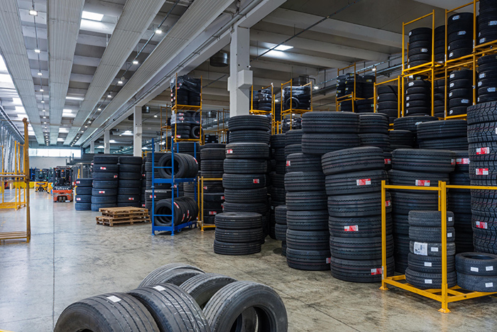***Aldo Bigatti, Sales & Marketing Director for the Light Business Unit at Gewiss**, added the following*: “For us, working with Yokohama has been an interesting opportunity, enabling us to collaborate with a company that is very sensitive to the environmental issues of energy efficiency and best working conditions. We are pleased to have contributed to improving the lighting conditions within the company, fully meeting their requirements as indicated to us at the start of the project."*