January 2017

**VILLA BELVEDERE, TIMELESS COMFORT**

***GEWISS solutions for domotics, energy and lighting in the prestigious Villa Belvedere.***

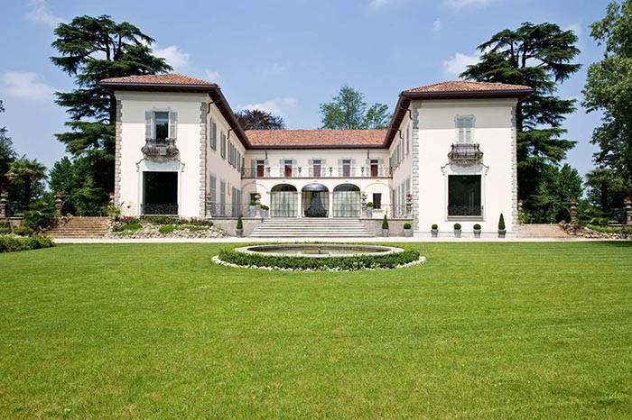Villa Belvedere is an **ancient residence** in the Lombardy region which, at the turn of the new millennium, was subject to a careful and skilful restoration, designed to preserve the original architectural volumes of the space whilst enhancing each of the separate environments with a **contemporary touch.** The interior design project was managed by architect and designer **Ettore Mocchetti** (also director of the monthly publication AD - Architectural Digest), who studied the detail of each and every solution in order to ensure that all of the customer's requirements were met.

The new complex is the result of an intense search for the beauty which is found in every detail. The inhabitants of this exclusive home are immersed in a seductive atmosphere, pampered by the best that **design** and **technology** can offer. The rooms are warm, welcoming and comfortable. Modern, contemporary style is combined, in a subtle play of cross-references and influences: the warmth of modernity conveys a sense of delicacy and sweetness to the hi-tech solutions that are dotted throughout the building, while the contemporary shapes and materials enhance the expressive potential of the entire residence.

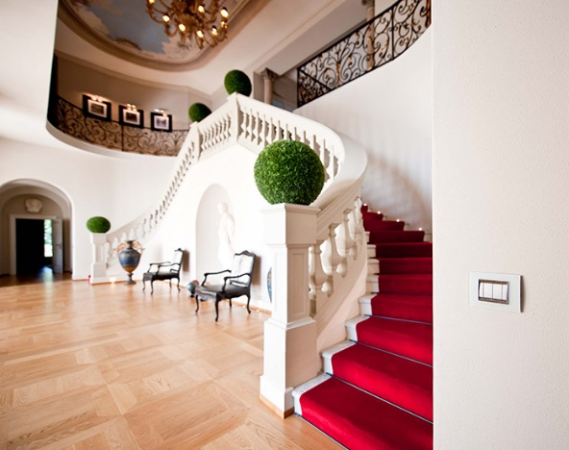GEWISS has contributed to the identity of this prestigious home with a comprehensive range of **domotics**, energy and lighting solutions. Indeed, the GEWISS integrated electrical system is present on each wall of the house, with the seductive geometries of the Lux and Flat plates and the new **Chorus** international domotics system, and more. The management of the building is entrusted to domotic system management devices, for controlling energy distribution and lighting in both internal and external rooms and spaces.

The LUX and Flat plates by GEWISS were selected to adorn the walls of the Villa.

The modern, delicate lines of the **LUX** marry high-tech, contemporary flair with the sophisticated, elegant taste of tradition, lending these spaces a feeling of refinement and familiarity. Glass, with its soft, icy nuances, and brushed aluminium were chosen for the finishes, bringing a degree of discretion and authority to the different home environments. The stylistic purity of glass enhances the furnishings, successfully blending with the strong personality of the space; similarly, the neutrality of ice throws the delicate colours of the drapes that decorate the windows into relief, drawing the attention to the shades on the newly-restored antique plaster walls.

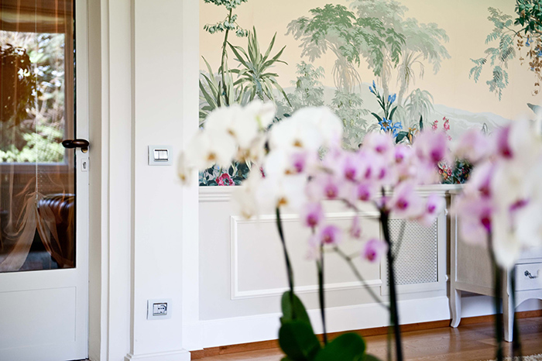The geometric rationality of the **Flat** is heightened by the lightness and sophistication of the surface that frames the command push-buttons, blending seamlessly with the furnishings throughout the villa, and lending each space a feeling of chromatic and material harmony. The button keys, in white tones and metallic titanium, invite the soft, delicate touch of a finger. A wide range of devices completes the choice of push-buttons: presence detectors for the automatic switch-on of lights, anti black-out lamps, leak detectors, TV and SAT socket-outlets, telephone/audio/video connectors, and network cabling.

Reflecting the style of the villa, Chorus expresses a surprising mix of **technology** and **design**, rationality and emotion. In addition to the design, which blends harmoniously with the surrounding environment, Chorus is also discreetly involved in managing the main functions of the home, from thermoregulation to lighting, control of electrical loads and management of protection devices.

All this can be achieved via the Master control panel, the GEWISS Master touch screen device that allows all **the functions of the home** to be **controlled** from a single point: lighting devices, roller shutters, air-conditioning system, irrigation system, alarm devices, video entryphone and video surveillance. And the owners of Villa Belvedere find it just as easy to control these functions even when not at home: the **system navigator** allows you to interact with your home via PC, tablet or smartphone with a standard browser. All with just a click.

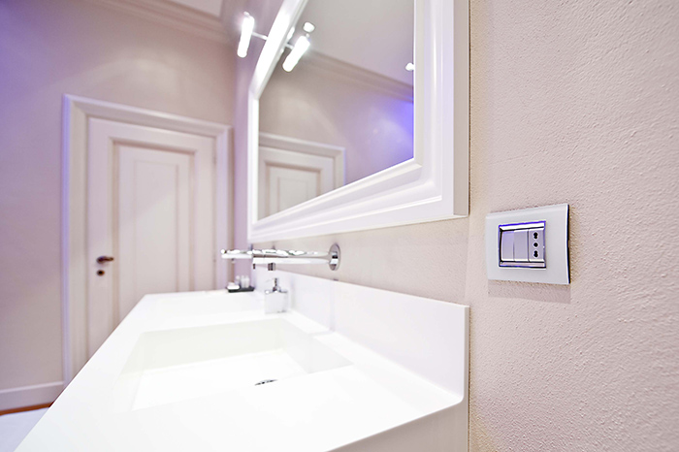The energy that makes it possible to enjoy the wonderful moments spent at Villa Belvedere is managed by the **GEWISS protection system**, which includes distribution boards (from the CVX range) and miniature **circuit breakers** from the **90 range**. Of all the devices capable of ensuring maximum safety, **ReStart with Autotest** is of particular note. When the power cuts out during a thunderstorm or as a result of a surge in voltage, this innovative device automatically re-activates it in less than ten seconds, having first verified that no system failure is present; in addition, the version with Autotest periodically checks the efficiency of the device by automatically performing the residual current protection test, without cutting power to the system.