November 2017

INCREASED COMFORT AND SAFETY IN THE SPORTING ENVIRONMENT WITH GEWISS TECHNOLOGY

The Olimpica Tennis courts are illuminated with SMART Light [4] technology.

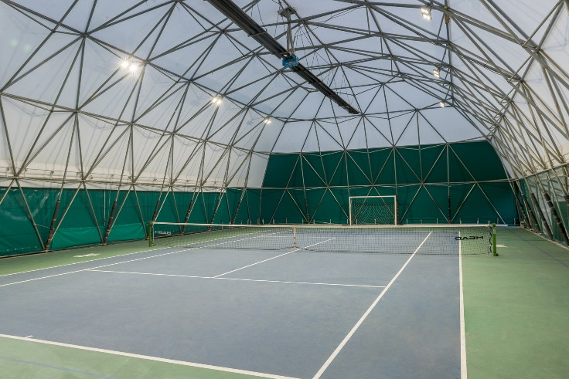The Olimpica Tennis sports facility in Rezzato chooses Gewiss lighting to illuminate five of its tennis courts. The centre has always been a reference point for sporty types in Brescia, and boasts a total of eight tennis courts, with four outdoor and four indoor courts with Play-It surfaces, a 5-aside indoor football pitch and an 18-hole minigolf course.

For the managers of the centre, the well-being of their users has always been the absolute priority. In this regard, **the lighting of the court is crucial for the physical and psychological well-being of players,** and as such, has a decisive effect on training and sporting performance. Accordingly, **Olimpica Tennis has turned to Gewiss technology** in order to meet the needs of its customers.

Indeed, a total of 40 **Smart [4] 5+5L devices** now illuminate 6 of the courts at the centre, the 4 outdoor courts plus one which is equipped with an inflatable cover spanning a width of 80 square metres, with surface area of 4,000 square metres in total. In addition to a clear improvement in visual comfort compared to the previous 400W floodlights, innovative Smart [4] LED technology also ensures complete safety for all athletes training at the centre.

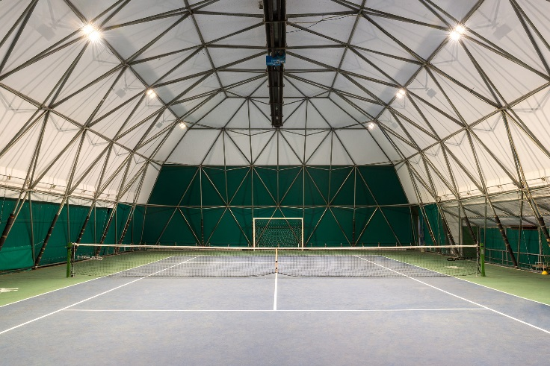In fact, with **DIN 18031-3 certification**, Smart [4] is the only technological solution that is perfectly suited to installation in gyms and sports centres. All versions of Smart [4] with bracket - LB | HB and FL - can now be surface and ceiling-mounted, thanks to the mechanical structure of the product which guarantees an **IK08 degree** of protection (index of resistance to impact). Furthermore, the fixing and connection systems were proven to ensure complete safety and functionality at the end of the test (36 standardised ball impacts at a speed of around 60km/h).

In addition to offering guaranteed safety, **Smart [4] technology is also synonymous with energy savings.** Following the installation of the Gewiss appliances, a reduction in the peak power used for each court was seen, dropping from 3.44 kW to 1.1 kW, resulting in an **estimated decrease in consumption of 68%**.

**Massimo Ogna**, manager and owner of the Olimpica Tennis sports facility, along with his father Angelo Ogna, comments on the choice: “*We are very pleased with the performance of our Gewiss Smart [4] devices. The difference compared to the previous lighting system is really clear: the light provided is much more uniform, and the improved visual comfort contributes to better tennis performance, whilst safeguarding the overall safety of our athletes*”.

**Aldo Bigatti**, sales director for Gewiss Lighting, makes the following statement: “*We are very honoured and proud to have been chosen as a partner in technology by Olimpica Tennis; for us, the sporting sector represents a key area of opportunity, thanks to the safety and comfort that our technology offers*”.

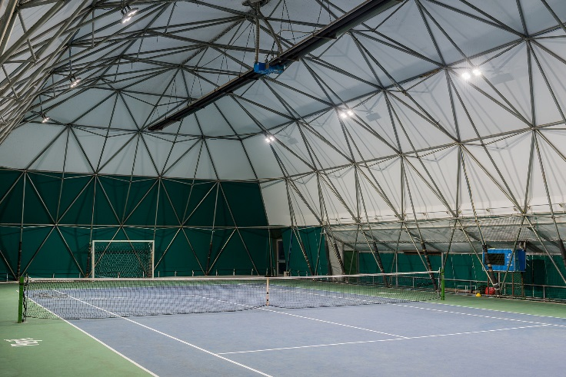

**Smart [4]**

The Smart [4] device enables maximum energy savings (from 50-80%) along with the best possible visual comfort. Smart [4] is versatile, functional, sustainable, extremely lightweight and adaptable; it can be transformed from a ceiling light/high bay to a floodlight, offering different performance levels for different contexts. The practicality of the device guarantees maximum lighting performance in any area of application, from industrial to sports environments, indoor or outdoor. And that's not all. The horizontal and vertical modularity of this product combines with easy installation and maintenance, the use of “green” construction materials (plastic and aluminium with an extremely low copper content), no environmentally harmful production processes, and easy disassembly at the end of its working life so the parts can be recycled.

Innovative Smart [4] technology is combined with clean, minimalist, simple style, typical of "Made in Italy" products. Indeed, the goal of the design was to emphasise the intrinsic characteristics of LED lamps: lightweight, small, practical and robust. These features were transferred to the end product, for unequalled levels of performance. The use of power LEDs with high colour performance, high efficiency optical systems (high bays and lenses) and the availability of multiple configurations make Smart [4] the ideal tool for minimising costs (for operation and maintenance) and maximising lighting performance, whilst ensuring optimum comfort in working environments.

The Smart [4] system can take six different optics: four with rotational symmetry (100°, 60°, 30°, 10°), one elliptic (60°x120°), and one asymmetric (52°). The luminous flux varies across the range from 2800 to 25,500 lumens (31-285W, losses included). From a mechanical perspective, this system can be secured in a number of ways: in the plate/spring version, the body is installed after the plate has been fixed, pressing slightly to trigger the steel spring; the watertight quick connector is then used to connect the device to the mains supply, without opening the power supply compartment. Smart [4] was designed and developed in order to render upgrades truly sustainable, enabling lighting systems to be adapted in a quick, easy and cost-effective manner.