November 2017

NATURE MEETS domotics

Chorus home automation technology systems feature in the latest jewel in the crown of the Nira Hotels & Resorts collection, the Nira Montana in La Thuile, nestled in the heart of a marvellous Alpine landscape.

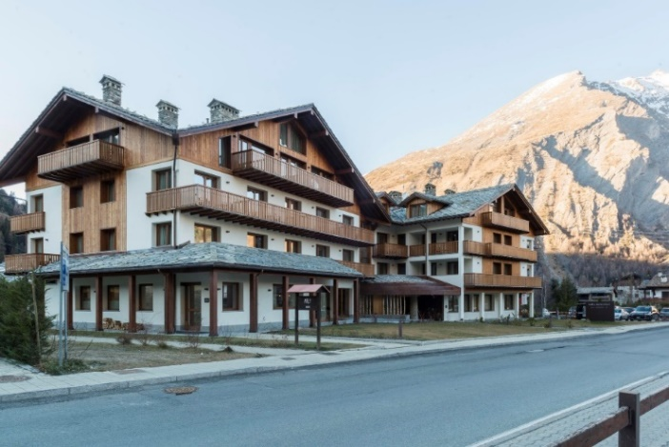Located in the picturesque town of La Thuile, in the heart of Valle d'Aosta region and at the foot of Mont Blanc, the Nira Montana Hotel is the first 5 star structure in this tourist resort, a year-round destination for mountain lovers. The hotel, which is surrounded by the great Monte Rosa, Gran Paradiso and Mont Blanc mountains, offers spectacular views of the surrounding landscape, and is the ideal starting point for exploring a region that boasts over 28 ski resorts and 4500 km of trails.

La Thuile is located in the north-western part of Valle d'Aosta region, and still retains an authentic mountain village atmosphere.

In winter, visitors can ski on both sides of the border between France and Italy, surrounded by the silent majesty of the Rutor glacier. Nordic walking, heli-skiing, free-riding and snowkiting are just some of the other winter activities that can be practised here, in addition to classic walking and snow-shoeing expeditions. The pleasant climate that characterises the summer months is perfect for hikes immersed in nature and for mountain sports. The Nira Montana provides a host of sporting and relaxation activities within the structure, with a large space dedicated to well-being. A fitness centre, an indoor pool, four treatment rooms and a wet area with sauna and steam room have earned the Nira Spa its fame within the hotel industry.

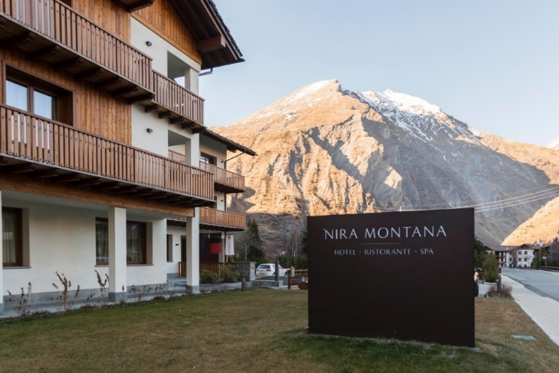The design of the large wellness area, like the rest of the building, is inspired by the natural elements that characterise the enchanting surroundings of the hotel. Wood and stone deliberately recall the traditional style of the rustic houses dotted throughout the valley. This helps to contribute to the sense of welcome that guests at Nira Montana are met with; visitors are made to feel right at home, in an environment that naturally combines design and comfort - where design echoes nature, and comfort goes hand in hand with technology and automation.

The Nira Montana hotel in La Thuile could be described as a "hotel of the world" which simultaneously reflects the traditions of its surroundings. Using nature as a model, it transforms this from its raw, outside state into a refined interior elegance, without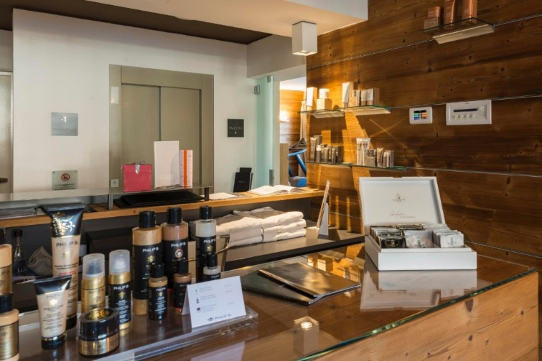 making any sacrifices. Comfort is also ensured, above all, by the high standards of automation according to which the building was constructed, guaranteeing maximum performance and reliability.

The solutions implemented throughout are taken from the GEWISS Chorus range of domotics systems, which include intelligent building control devices and energy distribution systems.

The adoption of domotics technology for the management of the facility **has guaranteed the energy-saving solutions and comfort** that only a truly intelligent system can offer. In the large wellness area, inspired by the natural elements, the Naxos Domo touch panel was installed, enabling all of the domotic functions in the room to be controlled.

The devices from the **Naxos range** are distinguished by their design, blending elegance with a cutting-edge, contemporary spirit: the innovative geometries of the solutions are designed to create a refined, understated style that accentuates both the architecture of the building and the design of the furnishing elements inside it. Available in black or white, it is suitable for surface-mounting.

"I very much appreciate the opportunities offered by these technologies," says Simone del Portico, interior designer for the hotel - "And I often suggest them in home environments too. I find that well-applied domotics solutions enable us to meet functionality requirements, whilst also coordinating with the design space."

Choosing the Chorus system has also allowed us to combine nature and luxury, creating refined design lines with minimal environmental impact.

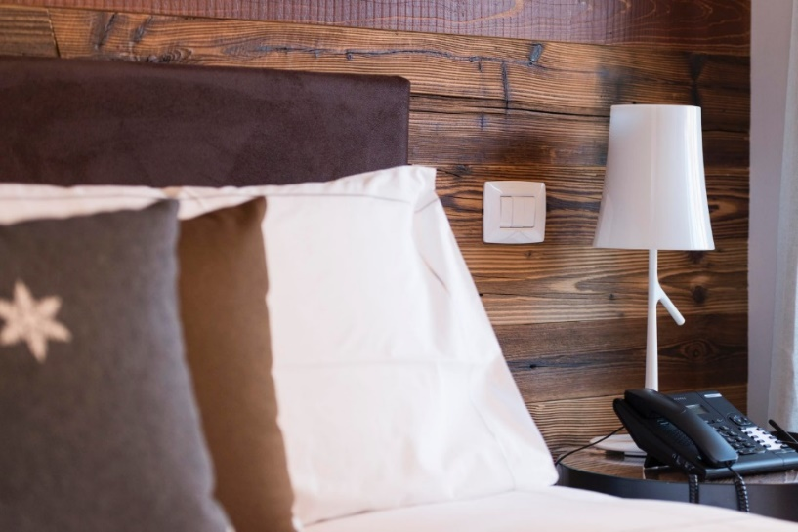"The same delicate balance has been maintained in the selection of accessories - continues Del Portico - from some of the leading contemporary design brands, with a view to achieving a suitable synthesis between the sobriety of the lines and the evocative power typical of traditional alpine design concepts."

The aesthetic harmony of the building was respected through the choice of **Chorus One** plates in milk white technopolymer for controlling the lights and other elements. A line of simple, discreet plates which enhance every environment.

The Chorus - Building Automation domotics system also includes KNX surface-mounting thermostats and 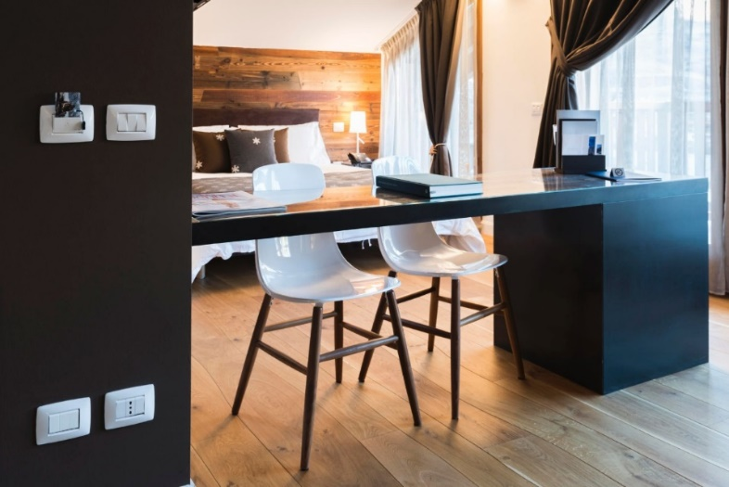KNX transponder units, installed in each of the 55 luxurious rooms. With simple shapes that are in harmony with the style surrounding them, these two elements fit perfectly into the integrated electrical system that GEWISS offers for both residential and industrial environments. A hotel such as Nira Montana can be viewed as a synthesis between these two areas, and as such, spaces dedicated exclusively to working activities like kitchens or laundry rooms are fitted with industrial-type products such as fixed flush-mounting IP44 and IP54 socket-outlets, along with fixed horizontal interlocked socket-outlets and straight mobile HP - IP44 / IP54 plugs.

To complete the system, a number of other single-block floor-mounted boards from the 47 - COX 630M range have also been fitted, along with modular floor-mounted boards from the 47 - CVX 630K series, containing devices for take-up of electricity in full safety, such as residual current circuit breakers, miniature circuit breakers and control switch disconnectors.

The design of the domotics system combined with the energy efficiency of these products make the GEWISS integrated electrical system the perfect solution for a hotel such as the Nira Montana in La Thuile, marrying its natural mountain inspiration with the ultimate in refined modern style.