November 2017

QUALITY AND DESIGN FOR ALL APPLICATIONS

The 46 QP family of products is brought up to date both in terms of form and substance, reinterpreting the canons of contemporary design and combining these with the cutting-edge technological research.

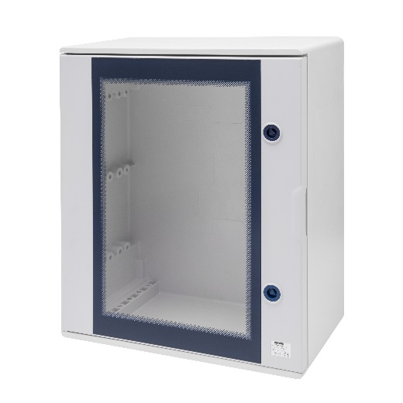The new 46 QP range is the ideal solution for the creation of automation and energy distribution boards. A complete system of surface-mounting watertight boards is available in seven different sizes, with blank or transparent door and capacity for up to 180 modules, meeting the most stringent regulatory requirements as well as adapting to even the most demanding environments.

The boards with transparent door have been designed not only to improve the aesthetic impact of these solutions in the environments in which they are installed, but above all to enhance their functionality: The internal visibility of the devices (both modular and non-modular) has been increased by approximately 20%. In addition, all versions (with either blank or transparent door) feature a more ergonomic and intuitive opening system, facilitating identification. The consistency of the design with the boards from the CVX range renders the style of these solutions unmistakable, inspired by the extreme attention to every detail and the stylistic flair that is typical of Italian design.

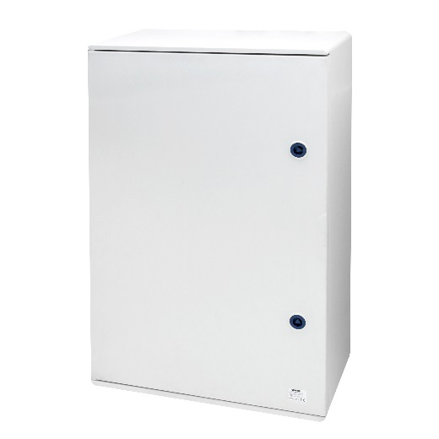The 46 QP boards are constructed with a reinforced polyester and fibreglass monobloc casing, which ensures excellent structural compactness with high resistance to static loads and impacts, providing the best possible product performance even in extreme environments. The new 46 QP boards are also resistant to chemical and atmospheric agents (rain, wind and hail) and exposure to UV rays, and are certified according to EN62208.

Developed in accordance with EN 62208, EN 60670-1 and EN 60670-24, the 46 QP boards provide total protection against dust (IP6X) and powerful jets of water (IPX6). The use of HALOGEN-FREE thermosetting materials (pursuant to the EN50267-2-2 standard) also helps to ensure maximum safety, even in the event of a fire. Compliance with the EN 61439-1, EN 61439-2 and EN 61439-4 standards also enables these boards to be used on building sites, providing high levels of operator safety.

In addition to superb performance and functional characteristics, QP boards also feature a quick assembly system (Fast & Easy) and a range of accessories that no other brand can rival.

The GEWISS energy management and distribution systems, which include the boards from the 46 QP range, can be perfectly integrated with a wide range of safety devices, characterised by advanced technology and highly sought-after design features. Solutions that meet the requirements of all areas of application whilst guaranteeing quality, safety and functionality.