November 2016
Green lighting, even in the most demanding environments
GEWISS LED Smart [4] lighting solutions illuminate the Pressofusioni Sebine industrial area.
Pressofusioni Sebine is a major company in Artogne (BS), dedicated to the die-casting of non-ferrous metals (aluminium, zamak, pressed brass) and the transformation of these materials into products that are mainly used in the small and large household appliances and automotive sectors, and in the mechanics sector in general. Founded in 1966, this historic company has built a reputation on the basis of its ability to deliver exclusive products, created in accordance with the technical specifications provided by the customer.
The meeting between Pressofusioni Sebine and GEWISS occurred as a result of an increasing need to modernise and improve the efficiency of the lighting systems at the foundry, as well as within the workshop and in the mould maintenance and deburring divisions. These environments are characterised by extremely demanding conditions, due to the presence of 6 melting furnaces, 20 aluminium die-casting systems and 4 ZAMAK die-casting systems. The operation saw 109 400W mercury vapour lamps being replaced with 84 Smart [4] HB - 5+5L 138W devices and 25 Smart [4] FL - 5L 69W devices.
From a performance perspective, the decision to use Smart [4] solutions, which are characterised by extreme ease and speed of installation, enabled production to continue even when the system was being built. And that's not all. Without increasing the number of appliances installed, lighting levels in the various departments were increased, leading to improved visual comfort and greatly reduced maintenance costs.
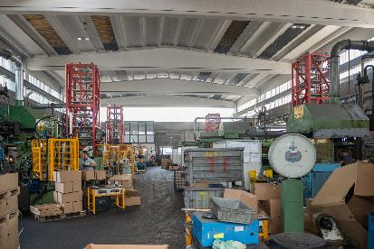
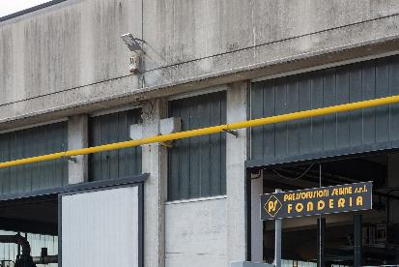
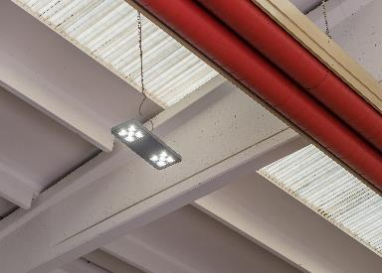
"The new lighting system has resulted in a significant improvement to the lighting in the various environments, above all in low light conditions in the evening and at night." - explained Giacomino Spandre, manager at the Pressofusioni Sebine foundry - "We have always focused on maintaining the quality of our working environments, paying close attention to the conditions in which our employees work. With Smart [4], we have been able to continue this commitment effectively, providing more efficient and effective lighting. Our satisfaction is mirrored by that of our staff, who have provided positive feedback on the visual comfort provided by these new luminaires.”
SMART [4], LIGHT QUALITY IS PRICELESS
The Smart [4] device enables maximum energy savings (from 50-80%) along with the best possible visual comfort. Smart [4] is versatile, functional, sustainable, extremely lightweight and adaptable; it can be transformed from a ceiling light/high bay to a floodlight, offering different performance levels for different contexts. The practicality of the device guarantees maximum lighting performance in any area of application, from industrial to sports environments, indoor or outdoor. And that's not all. The horizontal and vertical modularity of this product combines with easy installation and maintenance, the use of “green” construction materials (plastic and aluminium with an extremely low copper content), no environmentally harmful production processes, and easy disassembly at the end of its working life so the parts can be recycled.
Innovative Smart [4] technology is combined with clean, minimalist, simple style, typical of "Made in Italy" products. Indeed, the goal of the design was to emphasise the intrinsic characteristics of LED lamps: lightweight, small, practical and robust. These features were transferred to the end product, for unequalled levels of performance. The use of power LEDs with high colour performance, high efficiency optical systems (high bays and lenses) and the availability of multiple configurations make Smart [4] the ideal tool for minimising costs (for operation and maintenance) and maximising lighting performance, whilst ensuring optimum comfort in working environments.
The Smart [4] system can take six different optics: four with rotational symmetry (100°, 60°, 30°, 10°), one elliptic (60°x120°), and one asymmetric (52°). The luminous flux varies across the range from 2800 to 25,500 lumens (31÷285W, losses included). From a mechanical perspective, this system can be secured in a number of ways: in the plate/spring version, the body is installed after the plate has been fixed, pressing slightly to trigger the steel spring; the watertight quick connector is then used to connect the device to the mains supply, without opening the power supply compartment. Smart [4] was designed and developed in order to render upgrades truly sustainable, enabling lighting systems to be adapted in a quick, easy and cost-effective manner.

GEWISS, INNOVATION SINCE 1970
Development as a constant feature of management is the philosophy that has consistently guided the decisions made by GEWISS, from its establishment until today.
GEWISS was founded more than 40 years ago and, since its first day of operation, each and every action and decision has been led by quality-focused research and a drive to develop exceptional solutions. Over the years, this dedication to innovation has taken shape, in a company model which is based above all on continual investment in Research & Development.
Constant experimentation with new materials and technologies, a global vision of the concept of lighting technology and the formalisation of aesthetics which can be traced back to the unmistakable pillars of Italian design - these are the aspects which lie at the very heart of GEWISS lighting solutions. Together, these elements represent the perfect formula, enabling GEWISS to become a global partner in creating lighting systems designed for every room, every space and every location. Indeed, GEWISS products are perfect for indoor and outdoor installations, industrial contexts, commercial buildings (retail outlets, public buildings) and sports facilities, as well as for street and emergency lighting. The GEWISS lighting range includes architectural floodlights, residential/urban decorative devices, aluminium floodlights, street lighting and recessed and modular fittings for surface and ground installation.

