November 2017

The green light for optimising space and resources

GEWISS LED Smart [4] lighting solutions are at the heart of the new UHT milk production line at the Centrale del Latte di Brescia facility.

The Centrale del Latte di Brescia is a historic company: it was established in 1930 with a view to ensuring hygiene control in milk production, along with the daily distribution of milk. The company has never failed to deliver in this mission. Indeed, from 1931 to today, the Centrale del Latte di Brescia has continued production without a single interruption, not even for a day - even throughout the war. Over the course of this long and illustrious history, the Brescia-based company has become known for its extraordinary capacity for innovation, and for its receptive, open approach to new technologies.

In 2015, the Centrale del Latte di Brescia decided to create a second UHT milk production line: a technologically-advanced system with a range of innovative features, with a particular focus on optimising space and resources. In order to light the new plant, which spans more than 570 square metres, the company chose Smart [4] technologies by GEWISS: 31 LED lighting devices (4 Smart [4] - LB 4L and 27 Smart [4] - LB 5L) and 5 emergency devices (the emergency version of the Smart [4] - LB 4L), ensuring optimum lighting and high levels of comfort for all technicians working within the facility.

And that's not all. The Centrale del Latte di Brescia also decided to install GEWISS Street [O3] street lighting in the parking area for its distribution vehicles: a total of 15 700mA 2M devices which ensure excellent illumination of the area, improving visual comfort and increasing security.

*"To create the lighting system for the new production area, we were looking for technologically-advanced solutions combining design, energy savings, ease of installation and reduced maintenance costs."* - explains Mr. Donini, who was in charge of planning the system - *"And that's not all. The entire new production line is characterised by the way it succeeds in optimising space and resources. Accordingly, GEWISS Smart [4] technologies were the obvious choice: products that are capable of meeting all of our requirements, both in terms of function and aesthetics, enabling us to create a lighting system that offers optimal visual comfort and a pleasant aesthetic, without sacrificing environmental protection."*

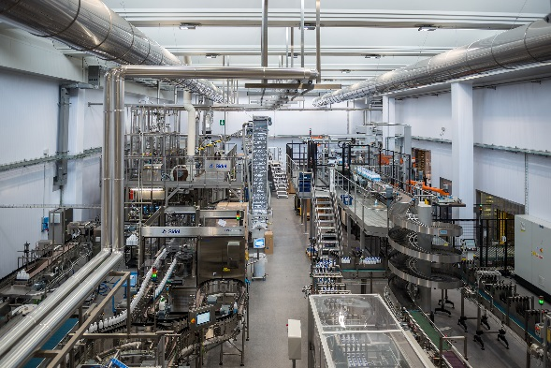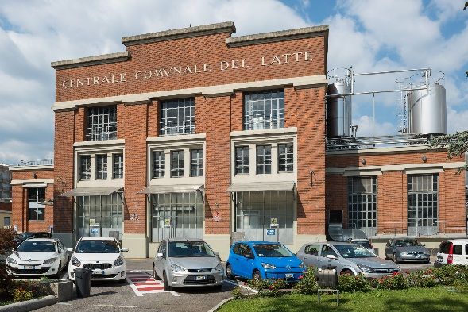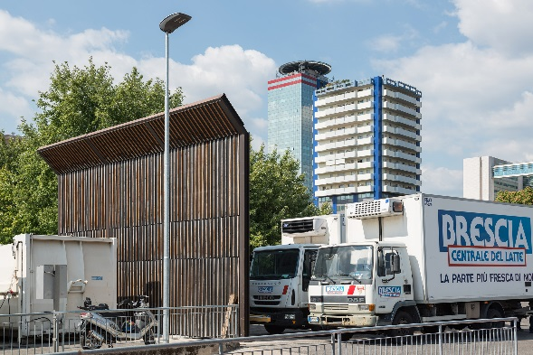

SMART [4], LIGHT QUALITY IS PRICELESS

The **Smart [4] device enables maximum energy savings (from 50 to 80%)** along with the best possible visual comfort. Smart [4] is versatile, functional, sustainable, extremely lightweight and adaptable; it can be transformed from a ceiling light/high bay to a floodlight, offering different performance levels for different contexts. The practicality of the device guarantees **maximum lighting performance in any area of application**, from industrial to sports environments, indoor or outdoor. And that's not all. The horizontal and vertical modularity of this product combines with easy installation and maintenance, the use of “green” construction materials (plastic and aluminium with an extremely low copper content), no environmentally harmful production processes, and easy disassembly at the end of its working life so the parts can be recycled.

Innovative Smart [4] **technology is combined with clean, minimalist, simple style**, typical of "Made in Italy" products. Indeed, the goal of the design was to emphasise the intrinsic characteristics of **LED lamps**: lightweight, small, practical and robust. These features were transferred to the end product, for unequalled levels of performance. The use of power LEDs with high colour performance, high efficiency optical systems (high bays and lenses) and the availability of multiple configurations make Smart [4] the ideal tool for minimising costs (for operation and maintenance) and maximising lighting performance, whilst ensuring optimum comfort in the work environment.

The Smart [4] system can take six different optics: four with rotational symmetry (100°, 60°, 30°, 10°), one elliptic (60°x120°), and one asymmetric (52°). The luminous flux varies across the range from 2800 to 25,500 lumens (31÷285W, losses included). From a mechanical perspective, this system can be secured in a number of ways: in the plate/spring version, the body is installed after the plate has been fixed, pressing slightly to trigger the steel spring; the quick watertight connector is then used to connect the device to the mains supply, without opening the power supply compartment. Smart [4] was designed and developed in order to render upgrades truly sustainable, enabling lighting systems to be adapted in a quick, easy and cost-effective manner.

**STREET [O3]**

Street [O3] is a street lighting device which ensures maximum installation efficiency for all lighting installations on any type of road, with reduced operating costs. It is fully compliant with current industry regulations. Street [O3] is available in a LED configuration with 2 (32 LED) to 5 (80 LED) modules, or in the CosmoPolis version.

All models offer an IP 66 degree of protection, belong to insulation class II and can house remote control devices. Versions of this solution with a dual-regime self-learning device are available, along with DALI versions. Street [O3] products can be installed on all pole systems, with or without side bracket, with diameters from 42 to 76 mm. A range of GEWISS poles and side brackets is also available, with a look that is designed to coordinate perfectly with Street [O3] devices, to enhance the aesthetic and add a distinctive character to the final installation.

The Street [O3] range is completed by the Street [O3] Maxi, which can now meet the lighting requirements of busy main roads and out of town routes, as well as all other open spaces where good lighting is required. This product is suitable for use in warm environments with high temperatures, and is immune to induced overvoltages higher than 6kV, in accordance with CEI EN 6100-4-5 (third party certification). The features of the devices ensure that the ideal thermal conditions are maintained, through dissipation systems that are directly in contact with the parts that generate heat. Further assistance is provided by the lateral aeration system. The combination of these two solutions provides an optimal exchange between the inside and the outside of the device, guaranteeing an excellent working life: B10L80 = 24,000h for Cosmopolis systems and B10L80 = 70,000h for LED systems. The condition cited for the B10L80 refers to at least 80% of the initial flow being maintained, with a percentage of lighting devices that do not meet this target of 10%.

|  |
| --- |
| ***GEWISS, INNOVATION SINCE 1970***  *Development as a constant feature of management is the philosophy that has consistently guided the decisions made by GEWISS, from its establishment until today.*  *GEWISS was founded more than 40 years ago and, since its first day of operation, each and every action and decision has been led by quality-focused research and a drive to develop exceptional solutions. Over the years, this dedication to innovation has taken shape, in a company model which is based above all on continual investment in Research & Development.*  *Constant experimentation with new materials and technologies, a global vision of the concept of lighting technology and the formalisation of aesthetics which can be traced back to the unmistakable pillars of Italian design - these are the aspects which lie at the very heart of GEWISS lighting solutions. Together, these elements represent the perfect formula, enabling GEWISS to become a global partner in creating lighting systems designed for every room, every space and every location. Indeed, GEWISS products are perfect for indoor and outdoor installations, industrial contexts, commercial buildings (retail outlets, public buildings) and sports facilities, as well as for street and emergency lighting. The GEWISS lighting range includes architectural floodlights, residential/urban decorative devices, aluminium floodlights, street lighting and recessed and modular fittings for surface and ground installation.* |