November 2017

SEKO gets a new look with GEWISS lights

GEWISS LED lighting solutions illuminate the SEKO plant in S. Rufina (RI).

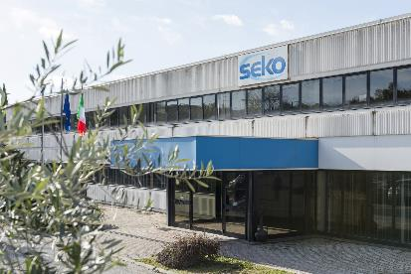SEKO is an important manufacturer of dosing pumps and systems. The company has become a global leader in many fields, providing innovative products and offering reliable solutions. The SEKO production processes rely on state-of-the-art technology: the production lines are designed to ensure the best possible quality and service anywhere in the world.

The management team at SEKO wanted to ensure that this quality was guaranteed in the S.Rufina plant (RI), through the implementation of GEWISS lighting systems. This operation focused on **modernising and upgrading the lighting systems**, increasing the efficiency of a pre-existing installation and updating this in order to ensure compliance with the regulations in force. Tests carried out in the field have demonstrated that the light provided by the old system was inadequate: as such, the amount of light emitted by the luminaires needed to be increased, sacrificing a small percentage of the energy savings. Despite this, the GEWISS lighting project has succeeded in reducing **energy consumption by around 55%**, from an estimated 39 kW of power to just 17.5 kW, with pay-back estimated within around 4 years. In addition, the lighting system is now fully compliant with current regulations.

The project implemented at the SEKO plant saw the **complete replacement of the existing luminaires with the most modern and efficient GEWISS LED lighting systems**. In the area dedicated to offices, quality lighting was guaranteed courtesy of the Astrid LED and Bolla 200 devices, with a total of 332 units (25 Astrid 60x60 ceiling lights with 36W of power, 24 Astrid Square 200x200 lights with 20W, 182 Astrid 60x60 flush-mounted lights with 36W, 74 Astrid 30x120 lights with 36W and 27 Bolla 200 lights with 12W). In the production and warehouse areas, 47 devices from the Smart [4] range were installed: 26 Smart [4] HB 4+4L 4000K, 4 Smart [4] LB 2+2L 4000K, 2 Smart [4] LB 4L 4000K, 10 Smart [4] LB 5L 4000K and 5 Smart [4] HB 5+5L 4000K. In the outside areas, 11 street lighting devices from the Street [O3] range were installed: 3 Street [O3] LED 3M 4000K with a power of 700mA and 8 Street [O3] LED 3M 4000K with a power of 700mA.

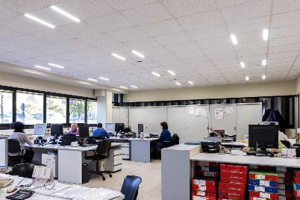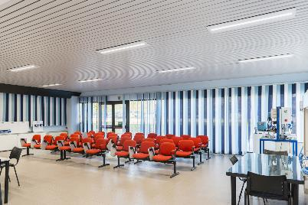

And that's not all. In addition, in the interests of bringing the entire facility in line with existing regulations, an **emergency lighting system** composed entirely of GEWISS Startec and Astrid devices was also implemented: a total of 118 devices, **guaranteeing plant safety even in case of power failure.**

"*We chose GEWISS solutions both due to the quality and light output that they offer and on the basis of the energy savings and low running costs they can achieve.*" - explained Sabatino Rossi, SEKO maintenance manager - *"The new lighting system guarantees optimum lighting for the various departments and offices, significantly improving visual comfort for those working within the facility. Not only that, but GEWISS devices, and the Smart [4] in particular, have proved to be extremely easy and fast to install, enabling production continuity even when the system is under construction.”*

SMART [4], LIGHT QUALITY IS PRICELESS

The **Smart [4] device enables maximum energy savings (from 50-80%)** along with the best possible visual comfort. Smart [4] is versatile, functional, sustainable, extremely lightweight and adaptable; it can be transformed from a ceiling light/high bay to a floodlight, offering different performance levels for different contexts. The practicality of the device guarantees **maximum lighting performance in any area of application**, from industrial to sports environments, indoor or outdoor. And that's not all. The horizontal and vertical modularity of this product combines with easy installation and maintenance, the use of “green” construction materials (plastic and aluminium with an extremely low copper content), no environmentally harmful production processes, and easy disassembly at the end of its working life so the parts can be recycled.

Innovative Smart [4] **technology is combined with clean, minimalist, simple style** , typical of "Made in Italy" products. Indeed, the goal of the design was to emphasise the intrinsic characteristics of **LED lamps**: lightweight, small, practical and robust. These features were transferred to the end product, for unequalled levels of performance. The use of power LEDs with high colour performance, high efficiency optical systems (high bays and lenses) and the availability of multiple configurations make Smart [4] the ideal tool for minimising costs (for operation and maintenance) and maximising lighting performance, whilst ensuring optimum comfort in the work environment.

The Smart [4] system can take six different optics: four with rotational symmetry (100°, 60°, 30°, 10°), one elliptic (60°x120°), and one asymmetric (52°). The luminous flux varies across the range from 2800 to 25,500 lumens (31÷285W, losses included). From a mechanical perspective, this system can be secured in a number of ways: in the plate/spring version, the body is installed after the plate has been fixed, pressing slightly to trigger the steel spring; the watertight quick connector is then used to connect the device to the mains supply, without opening the power supply compartment. Smart [4] was designed and developed in order to render upgrades truly sustainable, enabling lighting systems to be adapted in a quick, easy and cost-effective manner.

ASTRID LED: COMFORT AND SUSTAINABILITY

ASTRID LED is the innovative line of professional flush-mounting devices with LED technology designed for different application areas such as offices, hotels, reception facilities, and all areas of the commercial sector in general. A range which is able to guarantee high levels of lighting performance, excellent energy savings, and good visual comfort.

The range includes:

* **ASTRID ROUND.** Circular, flush-mounting downlights available with two different types of optic: wide beam (for diffuse, even lighting) or narrow beam (for more specific, accentuated lighting).
* **ASTRID SQUARE.** Square, flush-mounting downlights, available with two different types of optic and in two different colour temperatures (3000 and 4000 K). The DALI version can be ordered, for light flow regulation.
* **ASTRID 60x60***.* 60x60cm modular flush-mounting elements, available with three different types of optic: diffused (for soft, extensive lighting), prismatic, and dark light (both ideal for installation in offices and conference rooms, even where video terminals are used).
* **ASTRID 75.** Decorative flush-mounting devices with a 10W (1000lm) LED light source. In all the versions, the finish ring in die-cast aluminium can be adjusted to facilitate the direction and focus of the light beam, and is available in either glossy white, metallic aluminium, gold or bronze.

The ASTRID LED flush-mounting downlights can guarantee energy savings of more than 50% compared with conventional solutions using T8 electronic fluorescent lamps. This means that companies and reception facilities can considerably reduce their costs: in fact, at least 40% of energy consumption can be attributed to lighting, and over 70% of existing installations are based on obsolete, inefficient technologies.

STREET [O3]

Street [O3] is a street lighting device which ensures maximum installation efficiency for all lighting installations on any type of road, with reduced operating costs. It is fully compliant with current industry regulations. Street [O3] is available in a LED configuration with 2 (32 LED) to 5 (80 LED) modules, or in the CosmoPolis version.

All models offer an IP 66 degree of protection, belong to insulation class II and can house remote control devices. Versions of this solution with a dual-regime self-learning device are available, along with DALI versions. Street [O3] products can be installed on all pole systems, with or without side bracket, with diameters from 42 to 76 mm. A range of GEWISS poles and side brackets is also available, with a look that is designed to coordinate perfectly with Street [O3] devices, to enhance the aesthetic and add a distinctive character to the final installation.

The Street [O3] range is completed by the Street [O3] Maxi, which can now meet the lighting requirements of busy main roads and out of town routes, as well as all other open spaces where good lighting is required. This product is suitable for use in warm environments with high temperatures, and is immune to induced overvoltages higher than 6kV, in accordance with CEI EN 6100-4-5 (third party certification). The features of the devices ensure that the ideal thermal conditions are maintained, through dissipation systems that are directly in contact with the parts that generate heat. Further assistance is provided by the lateral aeration system. The combination of these two solutions provides an optimal exchange between the inside and the outside of the device, guaranteeing an excellent working life: B10L80 = 24,000h for Cosmopolis systems and B10L80 = 70,000h for LED systems. The condition cited for the B10L80 refers to at least 80% of the initial flow being maintained, with a percentage of lighting devices that do not meet this target of 10%.

|  |
| --- |
| ***GEWISS, INNOVATION SINCE 1970***  *Development as a constant feature of management is the philosophy that has consistently guided the decisions made by GEWISS, from its establishment until today.*  *GEWISS was founded more than 40 years ago and, since its first day of operation, each and every action and decision has been led by quality-focused research and a drive to develop exceptional solutions. Over the years, this dedication to innovation has taken shape, in a company model which is based above all on continual investment in Research & Development.*  *Constant experimentation with new materials and technologies, a global vision of the concept of lighting technology and the formalisation of aesthetics which can be traced back to the unmistakable pillars of Italian design - these are the aspects which lie at the very heart of GEWISS lighting solutions. Together, these elements represent the perfect formula, enabling GEWISS to become a global partner in creating lighting systems designed for every room, every space and every location. Indeed, GEWISS products are perfect for indoor and outdoor installations, industrial contexts, commercial buildings (retail outlets, public buildings) and sports facilities, as well as for street and emergency lighting. The GEWISS lighting range includes architectural floodlights, residential/urban decorative devices, aluminium floodlights, street lighting and recessed and modular fittings for surface and ground installation.* |