November 2016

Innovation, technology and comfort

GEWISS’ Chorus home automation system is the protagonist in a new architectural project designed by Arch. Ianni.

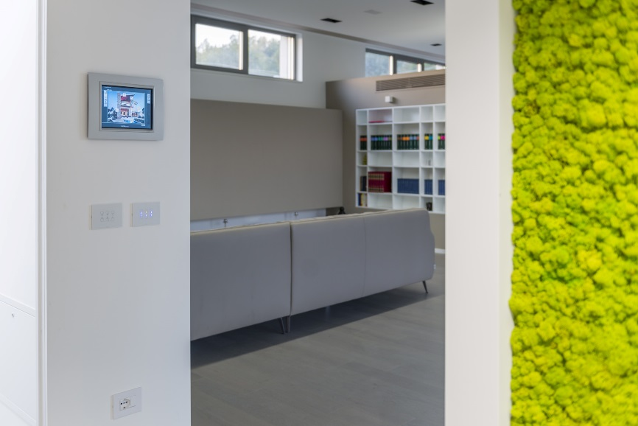In the hills of Casalvieri (FR) there’s a residential space where modern lines take the starring role. A living space of 250 square meters, created by Arch. Enrico Ianni, where GEWISS’ Chorus home automation system carves out an important role. It’s an ode to innovation and technology, combined in a spectacular way to create a house that responds to every need of its inhabitants.

The architectural design is characterized by a strong contemporary personality. Sharp lines merge with more rounded shapes, enhanced by LED lights, to create the ideal conditions for any moment. The technological solutions delicately wrap up every part of the space, ensuring the user is in the utmost comfort while providing the warmth that a living space requires.

The technological core of the house is provided by the Chorus home automation system by GEWISS: a series of cutting-edge solutions that guarantee safety, comfort, design and energy savings. It is a new way of viewing the home, focussing primarily on people and their needs within the home and improving the quality of living spaces.

In Arch. Ianni’s project every solution was carefully studied to fully exploit the potential of home automation: smart climate control and energy management, safety and security, flexibility. By skillfully combining thermostats and programmable thermostats, finely-tuned climate control configurations are created, by setting different temperatures in each room to promote energy efficiency. The intruder alarm system watches silently over the house, providing extra protection. At the same time, the sensors ensure safety in the home, providing real-time protection against potentially dangerous faults or anomalies in the systems themselves. Finally, the domotics panels provide control over all the home automation functions, with the possibility of operating the most complex scenes whilst checking the status of the home automation system at any time.

The attractive Chorus plates are a design feature of the walls, including charming details that catch the eye: a perfect alchemy bringing together beauty and simplicity, sophistication and spontaneity. The purity of glass, the lightness of the touch commands, and the elegance of the illuminated symbols of the ICE Touch plates combine style with a high-tech spirit, adding a touch of luxury and technology to every space ; the geometric lines of GEO plates reflect the refined lines of the building to give each space a striking and pleasing atmosphere.

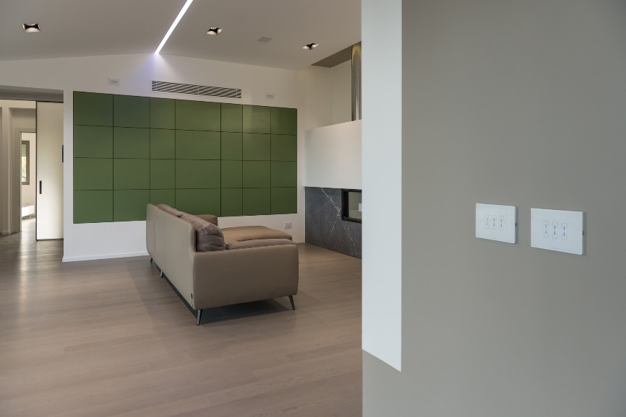"*GEWISS' home automation system* *allowed us to combine the best functional and aesthetic solutions,* " explains Arch. Enrico Ianni. "*We wanted to create a home where each space is able to convey a feeling of comfort and well-being. Choosing Chorus allowed us to maximise the visual impact of each environment and to build a living dimension able to meet the daily needs of those who live in the house."*

"The *Chorus home automation system* *allowed us to meet all the needs of our client.,*" says Erminio De Marco, owner of Dmdomotica, leading the design and installation of the home automation system. " *In particular, we focused on the integration of heating, intruder protection and lighting systems, with a particular focus on enabling the user to control them remotely. The domotics panels made managing the home easier, allowing the switching on and off of lights as well as controlling all the shutters from different rooms. That’s an important aspect, considering that the property extends over several floors. The home automation system Chorus also features another advantage: the KNX communication protocol. An open standard that enables integration with other devices and equipment, as well as expansion of the system in the future.* "

