November 2016

Style you can touch

With the new GEWISS ICE Touch KNX touchscreen panel with interchangeable symbols you can easily customise your controls.

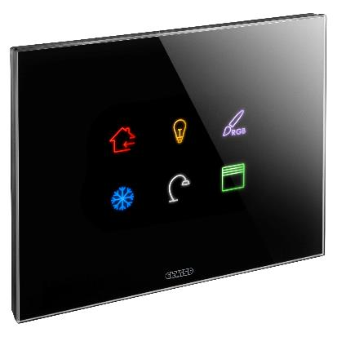GEWISS has updated the Chorus ICE Touch commands introducing **the new ICE Touch KNX touchscreen panels with interchangeable symbols**. Available in KNX and KNX Easy versions, the new touchscreen panels are a highly customisable design solution to control KNX home automation systems.

The new touchscreen panels meet the most sophisticated technological and design requirements and represent **a new frontier in illuminated devices**. The new ICE Touch KNX devices offer an entirely new experience: a home which reflects any change with just one touch. A perfect alchemy that brings together the purity of glass, the detail of the touch commands, and the elegance of the illuminated symbols.

**The coloured, customisable illuminated symbols**, enhance the elegance of the glass plate, which is available in three colours: pure white, modern titanium and sophisticated black. The new ICE Touch KNX devices translate the illuminated control device into a multi-sensory experience, combining touch with sight (in the multi-color backlighting), and sound (supplied by the acoustic features).

The new touchscreen panels have 6 touch-sensitive areas, equipped with integrated capacitive sensors and RGB backlighting, with 6 interchangeable, individually illuminated symbols. For even more choice, included in the box are 160 easily recognisable function icons for a full range of settings and operational options.

With the new ICE Touch KNX push buttons, illuminated panels can now **create the ideal condition for any moment**. The “soft reduction” command regulates the light level and the volume of the buzzer, with the possibility of adjusting the environment at any hour. The integrated proximity sensor enables you to raise the light level simply by your drawing hand closer. The ‘night’ backlight, with customisable colour options, helps you easily locate the illuminated panel in low light conditions.