November 2016

FASHION GROUP REVAMPS WITH GREEN LIGHTING

Miroglio Group’s M2LOG logistics hub lights up with GEWISS Smart[4] technology.

The Miroglio fashion group has broadened its sustainability model to include its M2LOG Logistics Centre at Pollenzo, Cuneo, Italy - a branch which is dedicated to managing the supply chain and is a benchmark for integrated logistics applied to textiles and clothing. M2LOG chose GEWISS’ Smart[4] innovative technology to renew the lighting system of its Pollenzo hub. Together with a hub located in Castagnole Lanze in nearby Asti, which manages the logistics for its fabrics and yarns, the two hubs cover an area of 90,000 square meters.

Handling 20 million garments and 20 million meters of textiles annually, and with up to 1 million garments shipped every week, the M2LOG Hub is the ideal logistics partner for companies operating in the fashion industry. The innovative and cutting edge plants that handle and sort textiles with advanced stock management systems guarantee high standards of excellence and quality. These same standards were applied to the selection process for M2LOG’s new lighting system.

M2LOG enlisted Sofisolar, a company specialising in energy efficiency for buildings, to assess its energy requirements, define a preliminary proposal and the return on investment. Sofisolar selected GEWISS lighting as the best solution to meet M2LOG’s brief of improved energy efficiency, sustainability as well as visual comfort for its employees. This led to the replacement of approximately 3,400 older generation fluorescents with 3,000 Smart[4] fittings, located in 4 of Pollenzo’s 7 Hubs. The new lighting system reduced energy consumption from 547,728 kWh/year to 283,152 kWh/year, for a 50% reduction (264,576 kWh/year), equal to 52 tons of oil or 101 tonnes of CO2.

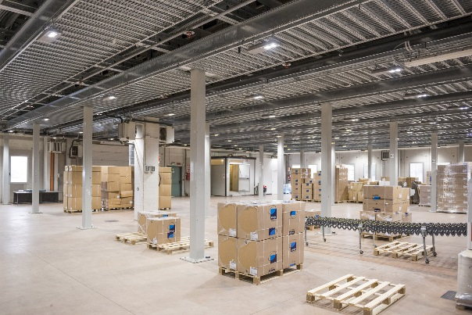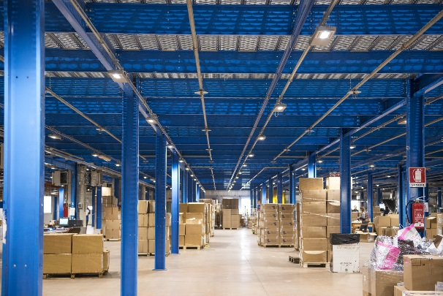"*The Miroglio Group has been involved in improving energy efficiency and eco-sustainability for many years*" says Piero Abellonio, Buying and Logistics Director of the Group. "*Our investment in the most advanced technologies over the last three years illustrate this. With this new project, in partnership with GEWISS, we achieved our goal to reduce CO2 emissions by focusing on renewable energy. The same approach, focussing on energy efficiency, will be carried out step by step over our entire network of retail outlets.*"

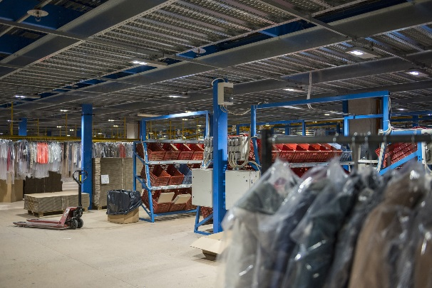"*Sofisolar strongly advocates LED technology applied to large working areas. We are very glad to have collaborated with such a prestigious customer as Miroglio Group and to have had the opportunity to adopt GEWISS’ lighting solutions, which are characterized by advanced technology and high reliability. This project was carried out to our great satisfaction and will be a stimulus for future growth*" said Walter Galli, Sofisolar Chief Executive.

Aldo Bigatti, GEWISS Commercial & Marketing Director - Light, added: "*As a Sofisolar partner, we are very pleased that Smart[4] was chosen for such an important and prestigious project. We are sure that the quality of our solutions will meet the needs of M2LOG, ensuring they meet the required performance levels.* "

SMART[4], QUALITY OF LIGHT IS PRICELESS

**Smart[4] ensures excellent energy savings (50% - 80%) and the best visual comfort**. Smart[4] is available in many configurations, rational, sustainable, extremely lightweight and versatile; it can be transformed from floodlight to ceiling light, offering different performance levels for different contexts. The practicality of the fitting guarantees **maximum lighting performance in any area of application**, from industrial to sports environments, indoor or outdoor. And that's not all. It has a number of key features: the possibility of horizontal and vertical installation; easy installation and maintenance; the use of “green” construction materials (plastic and aluminium with an extremely low copper content); no environmentally harmful production processes, and easy disassembly at the end of its working life so the parts can be recycled.

Smart[4] is **innovative technology enclosed in a minimalist**, sharp, linear style with a definite Italian feel. The design aim, in fact, was to emphasise the typical characteristics of **LED lamps**: lightweight, small, practical and robust. These features were transferred to the end product, providing it with unequalled performance levels. The use of power LEDs with high colour performance, high efficiency optical systems (high bays and lenses) and the availability of multiple configurations make Smart[4] the ideal tool for minimising costs (for operation and maintenance) and maximising lighting performance, whilst ensuring optimum comfort in the work environment.

The Smart[4] system can take six different optics: four with rotational symmetry (100°, 60°, 30°, 10°), one elliptic (60°x120°), and one asymmetric (52°). In the various types, the light flux ranges from 2800 lumen to 25,500 lumen (31÷285W, losses included). From a mechanical viewpoint, this system can be held in place in a number of ways: in the plate/spring version, the body is installed after the plate has been fixed, pressing slightly to trigger the steel spring; the quick watertight connector is then used to connect the device to the mains supply, without opening the power supply compartment. Smart[4] was designed and developed as a system for making upgrades truly sustainable, so that lighting systems could be adapted in a quick, easy and cost-effective manner.

|  |
| --- |
| ***M2LOG LOGISTIC HUB***  *M2LOG was born in the North West of Italy as a spin-off of the Miroglio Group dedicated to supply chain management. M2LOG is a benchmark for integrated logistics in the textile and clothing industry, with more than half a century’s fashion industry experience. Miroglio Group is an international leader in the textiles and apparel industry. It was established in 1947 and is present around the globe in 34 countries with 49 business operations, 3 production sites and over 1,300 single-branded stores. In the world of fashion, Miroglio Group creates, produces and distributes the collections for 11 clothing brands, including Reasons, Elena Miro and Caractère.* |

|  |
| --- |
| ***SOFISOLAR***  *Sofisolar evolved from the long-time experience of a team of professionals specialized in renewable energy with the mission of providing energy consulting services. Sofisolar builds turnkey projects for energy efficiency, starting from energy audits (whether they are individuals or companies, as well as accommodation facilities, hospitals and private or public institutions), identifying requirements and proposing solutions to meet them. Sofisolar supports its customers with competence and professionalism, supporting them from the preliminary project and planning of the return on investment to defining the final project and the subsequent realisation of the plant installation.* |

|  |
| --- |
| ***GEWISS, INNOVATION SINCE 1970***  *Development as a constant feature of management is the philosophy behind the choices made by GEWISS since it was founded.*  *GEWISS was founded forty years ago and since its first day of operation, research into quality and development of exceptional solutions have been the values that have guided every action and every decision. Over the years, this philosophy and mission toward innovation have shaped a company model based above all on continual investment in Research & Development.*  *Consistent experimentation into new materials and new technologies, the global vision of lighting technology concepts and formalisation of design related to the unmistakable principles of Italian design represent the most intimate and deepest dimension of the GEWISS lighting solutions. This perfect chemistry has allowed GEWISS to become a global partner in creating lighting systems designed for every room, every space and every location: In fact GEWISS products are perfect for indoor and outdoor installations, in industrial contexts, for buildings used for commercial purposes (retail outlets, public buildings) and for sports facilities, as well as for street and emergency lighting. The GEWISS lighting range includes architectural floodlights, residential/urban decorative devices, aluminium floodlights, street lighting and flushmounting elements (also modular) for the wall and ground.* |