November 2016

DUAL WALL SOLUTIONS FOR TOTAL PROTECTION

GEWISS presents the new line of coextruded FKCO pliable conduits, ideal for use with self-levelling liquid cements.

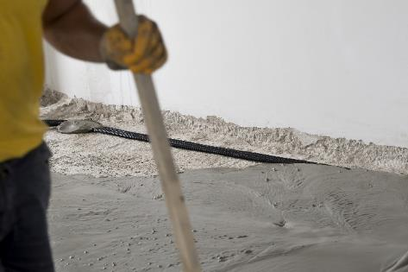In the building industry, techniques used in the construction of buildings and houses are constantly changing: today, this sector is increasingly reliant on eco-friendly materials with a low environmental impact, using new technologies that save both time and money. One of these is **self-levelling liquid cement**. This compound is characterised by its high degree of fluidity, allowing for significant reductions in screed laying times whilst guaranteeing high mechanical strength.

In order to meet the installation requirements associated with this construction solution, GEWISS has developed an innovative range of **coextruded FKCO pliable conduits.** Available in 4 diameters (from 20 to 40mm) and in six different colours to facilitate identification and differentiation between the various electrical lines, these new conduits are characterised by their **dual wall** structure, patented by GEWISS. This solution ensures the **total penetration of concrete components**, particularly those that are liquid. The material used for the outer wall also provides additional resistance to footfall, crushing and accidental knocks with loads on the worksite, even at low temperatures.

Thanks to its new profile, the FKCO conduit is now more flexible and solid, ensuring a considerable reduction in laying times. The new conduits are easy to unroll, stay in place and can be anchored very simply.

To facilitate the insertion of the cable-puller probe and the electric wires, the internal walls of the conduits measuring 20, 25 and 32mm in diameter are covered with a lubricant. This makes it easier for the wires to slide in, so that it is quicker and easier to use the conduits.

The FKCO range can be easily integrated with the FK15 range of conduits, delivering the most suitable technical and economical solution under any usage conditions. For example, the FKCO conduits can be used for floor-mounting systems buried in liquid cement, and the FK15 conduits for sub surface-mounting systems.