November 2016

GEWISS, ITALIAN EXCELLENCE AT THE HEART OF EXPO

GEWISS solutions for home and building automation, energy and lighting are protagonists at the international event which promotes Italian style and the ‘Made in Italy’ concept all over the world.

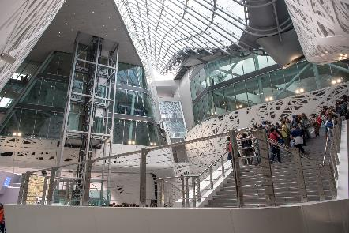EXPO Milano 2015 is a non-commercial Universal Exposition with some very unique and innovative features. Not only is it an exhibition but also a process, one of active participation among a large number of players around the theme of Feeding the Planet, Energy for Life. The exhibition is themed around the issues of nutrition and the resources of our planet. The idea is to open up a dialogue between international players, and to exchange views on these major challenges which impact on everyone.

These challenges involve every participant at EXPO, especially visitors, who can take a trip around the world, sampling the food and traditions of people from all over the globe, while reflecting on the consequences of their actions for future generations. Throughout, we are reminded of the need for a balance between innovation and environmental sustainability.

These are the same considerations that have always guided the economic and social choices of GEWISS. On the one hand, GEWISS designs products that range from cutting-edge solutions for smart homes and building management and control, electrical wiring accessories, electrical connection and distribution solutions, to the most recent and innovative LED lighting systems, designed for every room, every space and every location. On the other hand, GEWISS sustains a responsible business model that directs efforts towards the efficient consumption of energy resources and materials, a reduction in emissions, the development of safe working processes and environments and a rigorous respect of laws.

**GEWISS think about innovation as a tool to meet the needs of the world’s population, while respecting the environment.** GEWISS provided its know-how and experience to supply electrical solutions to a number of areas at EXPO 2015 – the architectural Padiglione Italia, the Cardo buildings, ‘Eataly’ structures, Service Areas and Country and Corporate Pavilions. With this major presence, GEWISS is acknowledged as a “Select supplier” of EXPO Milano 2015. The synergy and integration of the entire GEWISS offer - enclosures, distribution boards and cabinets, combined boards, modular and moulded-case devices, special containers - results in a technologically advanced solution, providing reliable energy distribution and safety to the millions of visitors who participate at the event.

**In the heart of Palazzo Italia**

Palazzo Italia, which is the symbolic heart of the whole Italian Pavilion and an expression of the Italian identity, will remain as a permanent exhibition after EXPO. The general concept of the Palazzo Italia is of an architectural landscape, in which the building assumes, through its very skin and volumetric distribution, the appearance of a forest in which visitors can immerse themselves and enjoy an emotive experience.

GEWISS contributed to the creation of that emotion, illuminating and enhancing the architectural forms of Palazzo Italia with the lighting LED system **Smart[4]**. An innovative technology enclosed in a minimalist, sharp, linear style with a definite Italian feel. The design of these fittings reflects the typical characteristics of LED lamps: lightweight, compact, practical and robust. These features were transferred to the end product, providing it with unequalled performance levels. Smart[4] is a totally green solution, both in terms of lighting efficacy and materials. It takes full advantage of the features of LED technology, ensuring top energy savings (50% - 80%) and the best visual comfort while the production processes and materials used all meet the most recent environmental sustainability requirements (rationalisation of resources and minimised environmental impact).

With Palazzo Italia symbolizing the essence of Italy, the unmistakable Italian style of GEWISS’ **LUX** range is an apt choice, with its refined lines and high-tech spirit. LUX is a range of plates for light switches with a contemporary form, combining a modern spirit with traditional elegance. The chromed frame and soft curves underline the plate's clean and essential shape, giving comfort and security to every room, with a touch of class.

And in the Confindustria Hall, GEWISS’ **DOMO CENTER** redefines the aesthetics of energy distribution; an innovative system column that integrates energy distribution, domotics, multimedia and safety devices. The form and customised finishes of DOMO CENTER are designed to complement GEWISS’ CHORUS domestic range: which along with the stylish LUX plates add a touch of personality, modernity and technology to the interior of Palazzo Italia. With an elegant mirror finish and the exclusive wall-suspended appearance of DOMO CENTER enhancing the architectural spaces of Palazzo Italia, the home automation system becomes an interior design feature.

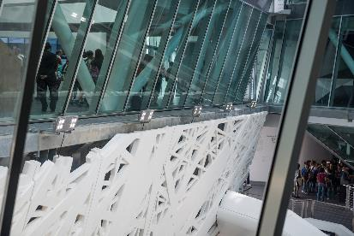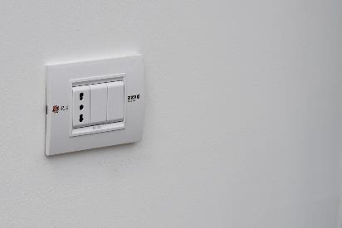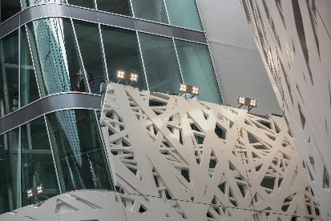**Serving Eataly**

The exceptional biodiversity of Italy is the order of the day in the Eataly Pavilion: a platform for promoting Italian regional gastronomic traditions. GEWISS solutions for the safe collection and distribution of energy feature heavily in over 8,000 square meters of Eataly. The **67IB** interlocked sockets guarantee strength and consistent high performance. In synergy with the **68 Q-DIN** distribution boards, they are the most widely used solution to transport energy in tertiary and industrial sectors. GEWISS’ **27 Combi** wall enclosures also offer dedicated protection to each facility and ensure total security in both traditional and heavy duty applications (versions are watertight with IP55 protection).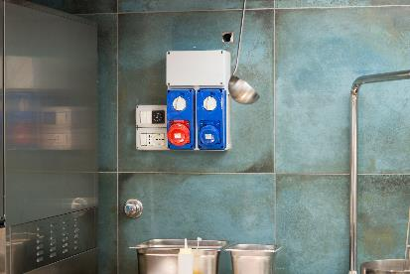

**Holy See Pavilion: “Not by bread alone”**

The Holy See Pavilion offers visitors a space to reflect on today’s perplexing issues, related to food and access to food. These issues highlight how the anthropological act of offering food is at the heart of the cultural and spiritual thinking it has generated within our history. The beating heart of the Pavilion is managed by **Master ICE**, the touch screen system navigator with exceptionally easy to use functions. With just the touch of a finger several devices are operated simultaneously to create the appropriate ambience at any time of day. With Master ICE, lighting scenarios are created which generate an atmosphere for reflection, encouraging visitors to contemplate aspects of daily life where they can act responsibly to change the world. The design of Master ICE is distinguished by its elegance and linear geometry, offering an overall appearance of balance and harmony.

**Entering the exhibition space**

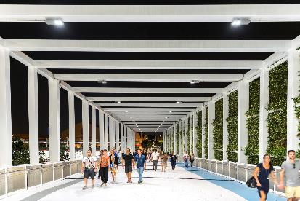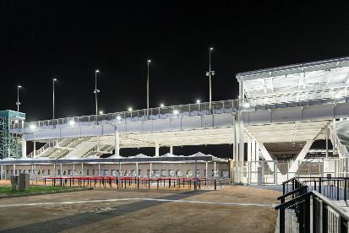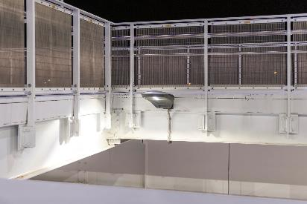GEWISS illuminates the entrances at EXPO and the path that leads visitors through the exhibition space with Smart[4] and **Street [O3]**, innovative solutions combining technological character, energy saving and high-quality design. Street [O3] is a street lighting device that guarantees lighting installations that maximise installation efficiency for any type of street, in full compliance with industry regulations and with the lowest operating costs. Street [O3] devices offer a IP 66 degree of protection, belong to insulation class II and can house remote control devices.

The contribution of GEWISS to EXPO does not end with supplying solutions and products, but goes far beyond that. Participating in EXPO means supporting the ‘Made in Italy’ concept, promoting the values that distinguish Italy from other countries: art, an appreciation of beauty, the richness and variety of the country, but also the social aspects and the spirit of being "Italian." EXPO is a unique opportunity to present the most advanced system solutions in the world, as well as promoting the GEWISS brand and products in the context of Italian excellence and building a wide network of contacts. EXPO has proved to be a space in which to think about the future, planning today for tomorrow.