November 2016

GREEN LIGHTING FOR LVF S.P.A. INDUSTRIAL PLANT

GEWISS LED lighting solutions light up manufacturing, assembly, shipping departments, and car park at LVF S.p.A.

LVF S.p.A. is a renowned, world-leading manufacturer of industrial valves for Oil, Gas, Chemical, Petrochemical, Power Generation and Marine Industries. With its headquarters in Italy, the company is founded on reliability, flexibility, security and respect for the environment; values which enable LVF S.p.A. to offer high quality yet competitively-priced products and services. In a bid to meet these same standards in every area of the business, LVF S.p.A. chose to replace its plant lighting with LED solutions from GEWISS.

By replacing existing fittings with 240 latest-generation eco-friendly **Smart [4] and Street [O3]** lighting solutions by GEWISS, LVF S.p.A. improved its lighting and energy-efficiency in production departments (including workshops, assembly and shipping areas) as well as car parks.

The GEWISS lighting project offers greatly improved energy savings and performance. The estimated consumption of the old plant was 320,000 kWh per year: the new devices have **reduced power consumption by 45%**, to an estimated 175,000 kWh. This improved energy efficiency has reduced dramatically the level of CO2 emissions to approximately 4,000 kg per year, the equivalent of more than 190 trees (small trees planted and grown for 10 years - source US environmental P.A.).

Smart [4], which offers simple and quick installation, enabled LVF S.p.A’s own production to continue while the project was installed. Lighting levels in each area were increased, while ensuring optimal visual comfort for personnel. Maintenance costs were greatly reduced, as Smart [4] is an extremely low maintenance solution - while the number of light fittings remained the same as the pre-existing installation.

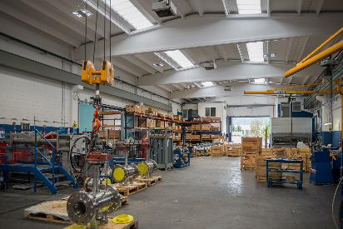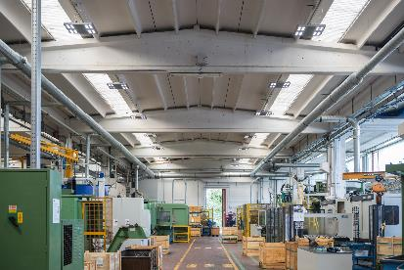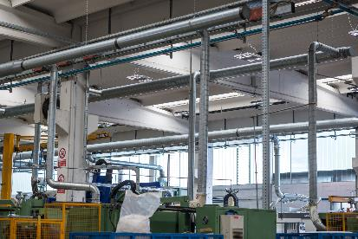"*We are very pleased to have collaborated with GEWISS,*" said Simone Sora, Information Technology Manager of LVF S.p.A. - "*We chose Smart [4] for its innovative features: reliability, performance and ease of installation. The new lighting system now allows us to continue to meet our environmental protection policy and to improve the quality of our workplace.*"

SMART[4], QUALITY OF LIGHT IS PRICELESS

**Smart[4] ensures excellent energy savings (50% - 80%) and the best visual comfort**. Smart[4] is available in many configurations, rational, sustainable, extremely lightweight and versatile; it can be transformed from floodlight to ceiling light, offering different performance levels for different contexts. The practicality of the fitting guarantees **maximum lighting performance in any area of application**, from industrial to sports environments, indoor or outdoor. And that's not all. It has a number of key features: the possibility of horizontal and vertical installation; easy installation and maintenance; the use of “green” construction materials (plastic and aluminium with an extremely low copper content); no environmentally harmful production processes, and easy disassembly at the end of its working life so the parts can be recycled.

Smart[4] is **innovative technology enclosed in a minimalist**, sharp, linear style with a definite Italian feel. The design aim, in fact, was to emphasise the typical characteristics of **LED lamps**: lightweight, small, practical and robust. These features were transferred to the end product, providing it with unequalled performance levels. The use of power LEDs with high colour performance, high efficiency optical systems (high bays and lenses) and the availability of multiple configurations make Smart[4] the ideal tool for minimising costs (for operation and maintenance) and maximising lighting performance, whilst ensuring optimum comfort in the work environment.

The Smart[4] system can take six different optics: four with rotational symmetry (100°, 60°, 30°, 10°), one elliptic (60°x120°), and one asymmetric (52°). In the various types, the light flux ranges from 2800 lumen to 25,500 lumen (31÷285W, losses included). From a mechanical viewpoint, this system can be held in place in a number of ways: in the plate/spring version, the body is installed after the plate has been fixed, pressing slightly to trigger the steel spring; the quick watertight connector is then used to connect the device to the mains supply, without opening the power supply compartment. Smart[4] was designed and developed as a system for making upgrades truly sustainable, so that lighting systems could be adapted in a quick, easy and cost-effective manner.

**STREET [O3]**

Street [O3] is a street lighting device that guarantees lighting installations that maximise installation efficiency for any type of street, in full compliance with industry regulations and with the lowest operating costs. Street [O3] is available in a LED configuration with 2 (32 LED) to 5 (80 LED) modules, or in the CosmoPolis version.

All models offer an IP 66 degree of protection, belong to insulation class II and can house remote control devices. Versions with two-speed self-learning device and DALI versions are also available.

The Street [O3] products can be installed on all pole systems, with or without a side bracket, with a diameter from 42 to 76mm. A range of GEWISS poles and side brackets is also available with a design coordinated to the Street [O3] devices, in order to maximise the design and characterise the final installation result.

The Street [O3] range is completed with the new Street [O3] Maxi, now able to meet the lighting requisites of busy main roads and motorways and, more generally, all open spaces where good lighting is required. It's suitable for use in warmer climates with high temperatures, and is immune to induced overvoltages higher than 6kV (in accordance with CEI EN 6100-4-5 - third party certification).

The device characteristics guarantee the maintenance of ideal thermal conditions through the dissipation systems directly in contact with parts that develop heat, assisted by additional side ventilation. The combination of the two solutions provides an optimal exchange between the inside and the outside, guaranteeing an excellent working life: B10L80≥24,000h for Cosmopolis systems and B10L80≥70,000h for LED systems. The B10L80 condition refers to maintaining at least 80% of the initial flow with a percentage of sources that do not respect the target of ≤10%.

|  |
| --- |
| ***GEWISS, INNOVATION SINCE 1970***  *Development as a constant feature of management is the philosophy behind the choices made by GEWISS since it was founded.*  *GEWISS was founded forty years ago and since its first day of operation, research into quality and development of exceptional solutions have been the values that have guided every action and every decision. Over the years, this philosophy and mission toward innovation have shaped a company model based above all on continual investment in Research & Development.*  *Consistent experimentation into new materials and new technologies, the global vision of lighting technology concepts and formalisation of design related to the unmistakable principles of Italian design represent the most intimate and deepest dimension of the GEWISS lighting solutions. This perfect chemistry has allowed GEWISS to become a global partner in creating lighting systems designed for every room, every space and every location: In fact GEWISS products are perfect for indoor and outdoor installations, in industrial contexts, for buildings used for commercial purposes (retail outlets, public buildings) and for sports facilities, as well as for street and emergency lighting. The GEWISS lighting range includes architectural floodlights, residential/urban decorative devices, aluminium floodlights, street lighting and flushmounting elements (also modular) for the wall and ground.* |

|  |  |  |  |
| --- | --- | --- | --- |
| **LIGHTING MANUFACTURING DEPARTMENTS** | | | |
|
|  |  |  |  |
| **PROJECT DATA** | Life cycle | 25 | |
| Annual operating hours | 3.200 | |
| Life cycle (hours) | 80.000 | |
| Reference area | Manufacturing departments | |
|  |  |  |  |
|  |  | **OLD PLANT** | **NEW PLANT** |
| **LIGHTING DEVICES** | **Type** | **SPOTLIGHT** | **GEWISS SMART[4]** |
| Type of lamp | HALIDE | LED |
| Optical system | / | / |
| Colour temperature | 4000 K | 4000 K |
| Colour rendering | 70 | 80 |
|  |  |  |  |
| **ENERGY CONSUMPTION** | Number of devices | **195** | **195** |
| Rated power **(Watt)** per unit | 430 | 248 |
| Total power **(Watt)** | 83.850 | 48.360 |
| Annual consumption **(KWh)** | 268.320 | 154.752 |
| **Energy savings (KWh) per year** | **113.568** | |
|  |  |  |  |
|  | Power factor kgCO2/KWh (Italy) | **0,53** |  |
|  | KgCO2 not emitted during life cycle | **142.210** |  |
|  | KgCO2 not emitted for year | **5.688** |  |
|  | “Saved” trees for year *** | **284** |  |

|  |  |  |  |
| --- | --- | --- | --- |
| **LIGHTING PARKING AREAS** | | | |
|
|  |  |  |  |
| **PROJECT DATA** | Life cycle | 12 | |
| Annual operating hours | 4.200 | |
| Life cycle (hours) | 50.400 | |
| Reference area | OUTDOOR | |
|  |  |  |  |
|  |  | **OLD PLANT** | **NEW PLANT** |
| **LIGHTING DEVICES** | **Type** | **STREET LIGHTING** | **GEWISS STREET [O3]** |
| Type of lamp | SODIUM | LED |
| Optical system | / | / |
| Colour temperature | 2700 K | 4000 K |
| Colour rendering | 50 | 65 |
|  |  |  |  |
| **ENERGY CONSUMPTION** | Number of devices | ***45*** | ***45*** |
| Rated power **(Watt)** per unit | 280 | 102 |
| Total power **(Watt)** | 12.600 | 4.590 |
| Annual consumption **(KWh)** | 52.920 | 19.278 |
| **Energy savings (KWh) per year** | **33.642** | |
|  |  |  |  |
|  | Power factor kgCO2/KWh (Italy) | **0,53** |  |
|  | KgCO2 not emitted during life cycle | **28.048** |  |
|  | KgCO2 not emitted for year | **2.337** |  |
|  | “Saved” trees for year *** | **117** |  |