November 2016

ELAH DUFOUR NOVI SWITCHES TO ‘GREEN’ LIGHTING

Fifteen hundred eco-friendly GEWISS fittings specified light up over 110,000 square meters.

With over 100 years of history and success, the **Elah Dufour Novi Group**, a leading Italian confectionery brand, **has chosen GEWISS as its technological partner for the restyling of its lighting systems** in Novi Ligure, near Alessandria, Italy. Elah’s goal was to improve the efficiency of its lighting systems, by reducing their environmental impact, energy consumption and maintenance costs as well as increasing the lighting performance and visual comfort. The new lighting project covered six areas of the company’s facilities: storage and warehouse buildings, packing areas, perimeters, car parks and offices. **More than 110,000 square metres (54,000 square metres of which were interior) were lit with 1,550 GEWISS technological solutions**.

Compared to the old system, with energy consumption at approximately 1,000,000 kwh, the new lighting system **enabled a high energy saving**, of over 600,000 kwh **equal to about 65%**, together with a drastic reduction of CO2 emissions: more than 250 tons per year - the equivalent of more than 10,600 trees (small trees planted and grown for 10 years - source US environmental P.A.).

Smart[4] devices were used to light up storage areas, warehouses, packing areas, perimeters and production areas , using High Bay (HB 4+4L), Low Bay (LB 2+2L – 4L and 5L 4000K), and Floodlighting (FL 4x5L). Street [O3] LED 1M / 3M - 4000K was specified for car parks, while the offices were installed with GEWISS’s new Astrid LED solution 60x60 45W - 4000K.

The benefits of **Smart[4]**, which include fast and easy installation, enabled production to continue while the project was installed; in addition, the installation increased the illuminance level by 40% in every area, achieved without increasing the number of fittings.

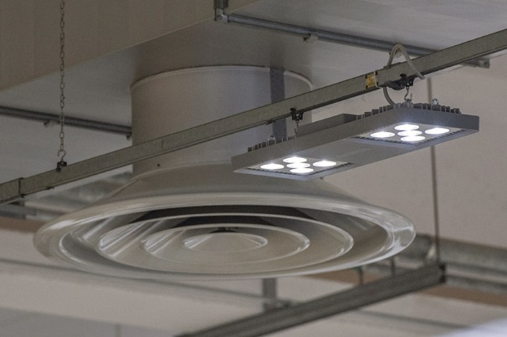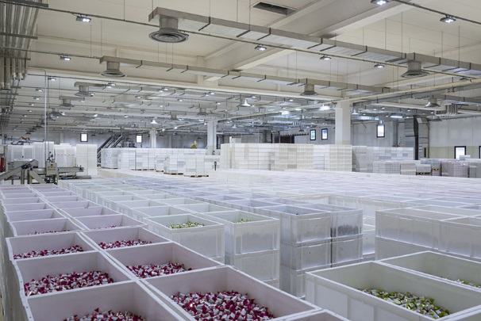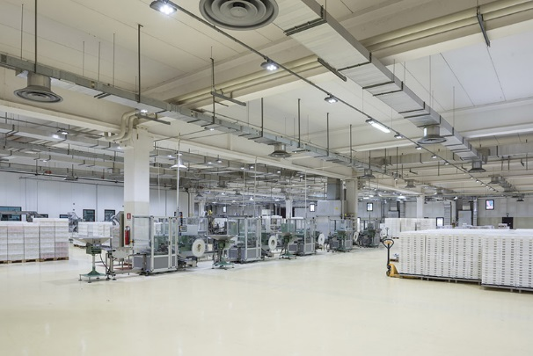Aldo Bigatti, GEWISS Commercial & Marketing Director - Light, commented: "*We are very honoured and proud to have been selected as a technological partner by Elah. The organisation demonstrated a truly progressive approach in taking on the solutions we proposed, to reach the goals of energy and performance efficiency of the lighting system. Therefore, we were able to achieve the highest level of quality to our mutual benefit.*"

Maurizio Ristori, Elah Dufour Spa Facilities Director, said: "*The decision to choose GEWISS solutions was made due to the innovative characteristics of Smart[4], to the quality control (such as the laboratory tests on the finished product), and due to the versatility of the installation. That they are also made in Italy is a plus point.*"

SMART[4], QUALITY OF LIGHT IS PRICELESS

**Smart[4] ensures excellent energy savings (50% - 80%) and the best visual comfort**. Smart[4] is available in many configurations, rational, sustainable, extremely lightweight and versatile; it can be transformed from floodlight to ceiling light, offering different performance levels for different contexts. The practicality of the fitting guarantees **maximum lighting performance in any area of application**, from industrial to sports environments, indoor or outdoor. And that's not all. It has a number of key features: the possibility of horizontal and vertical installation; easy installation and maintenance; the use of “green” construction materials (plastic and aluminium with an extremely low copper content); no environmentally harmful production processes, and easy disassembly at the end of its working life so the parts can be recycled.

Smart[4] is **innovative technology enclosed in a minimalist**, sharp, linear style with a definite Italian feel. The design aim, in fact, was to emphasise the typical characteristics of **LED lamps**: lightweight, small, practical and robust. These features were transferred to the end product, providing it with unequalled performance levels. The use of power LEDs with high colour performance, high efficiency optical systems (high bays and lenses) and the availability of multiple configurations make Smart[4] the ideal tool for minimising costs (for operation and maintenance) and maximising lighting performance, whilst ensuring optimum comfort in the work environment.

The Smart[4] system can take six different optics: four with rotational symmetry (100°, 60°, 30°, 10°), one elliptic (60°x120°), and one asymmetric (52°). In the various types, the light flux ranges from 2800 lumen to 25,500 lumen (31÷285W, losses included). From a mechanical viewpoint, this system can be held in place in a number of ways: in the plate/spring version, the body is installed after the plate has been fixed, pressing slightly to trigger the steel spring; the quick watertight connector is then used to connect the device to the mains supply, without opening the power supply compartment. Smart[4] was designed and developed as a system for making upgrades truly sustainable, so that lighting systems could be adapted in a quick, easy and cost-effective manner.

**STREET [O3]**

Street [O3] is a street lighting device that guarantees lighting installations that maximise installation efficiency for any type of street, in full compliance with industry regulations and with the lowest operating costs. Street [O3] is available in a LED configuration with 2 (32 LED) to 5 (80 LED) modules, or in the CosmoPolis version.

All models offer an IP 66 degree of protection, belong to insulation class II and can house remote control devices. Versions with two-speed self-learning device and DALI versions are also available.

The Street [O3] products can be installed on all pole systems, with or without a side bracket, with a diameter from 42 to 76mm. A range of GEWISS poles and side brackets is also available with a design coordinated to the Street [O3] devices, in order to maximise the design and characterise the final installation result.

The Street [O3] range is completed with the new Street [O3] Maxi, now able to meet the lighting requisites of busy main roads and motorways and, more generally, all open spaces where good lighting is required. It's suitable for use in warmer climates with high temperatures, and is immune to induced overvoltages higher than 6kV (in accordance with CEI EN 6100-4-5 - third party certification).

The device characteristics guarantee the maintenance of ideal thermal conditions through the dissipation systems directly in contact with parts that develop heat, assisted by additional side ventilation. The combination of the two solutions provides an optimal exchange between the inside and the outside, guaranteeing an excellent working life: B10L80≥24,000h for Cosmopolis systems and B10L80≥70,000h for LED systems. The B10L80 condition refers to maintaining at least 80% of the initial flow with a percentage of sources that do not respect the target of ≤10%.

**ASTRID LED**

The ASTRID range of LED flush-mounting lighting systems is designed to offer more comfort and sustainability in the working environment, creating a pleasant and elegant feel. ASTRID LED family is available in various versions:

* ASTRID ROUND - Circular LED flush-mounting downlights, available with two different types of optic: with a wide beam (for diffused, even lighting) or a narrow beam (for more specific, accentuated lighting)
* ASTRID SQUARE - Square LED flush-mounting downlights, available with two different types of optic and with two different colour temperatures (3000 and 4000 K)
* ASTRID 60x60 - Modular LED flush-mounting devices, 60x60cm, available with three different types of optic: diffused (for soft, extensive lighting), prismatic, and dark light (both ideal for installation in offices and conference rooms, even where video terminals are used)
* ASTRID 75 - Low energy flush-mounting devices with a 10W (1000 lm) LED lamp.

In all versions, the finish ring in die-cast aluminium can be adjusted to facilitate the pointing of the light beam, and is available in either glossy white, metallised aluminium, gold or bronze.

The ASTRID LED flush-mounting downlights can guarantee energy savings of more than 50% compared with conventional solutions using T8 electronic fluorescent lamps. This means that companies and reception facilities can considerably reduce their costs: at least 40% of energy consumption can be attributed to lighting, and over 70% of existing installations are based on obsolete, inefficient technologies.

|  |
| --- |
| ***GEWISS, INNOVATION SINCE 1970***  *Development as a constant feature of management is the philosophy behind the choices made by GEWISS since it was founded.*  *GEWISS was founded forty years ago and since its first day of operation, research into quality and development of exceptional solutions have been the values that have guided every action and every decision. Over the years, this philosophy and mission toward innovation have shaped a company model based above all on continual investment in Research & Development.*  *Consistent experimentation into new materials and new technologies, the global vision of lighting technology concepts and formalisation of design related to the unmistakable principles of Italian design represent the most intimate and deepest dimension of the GEWISS lighting solutions. This perfect chemistry has allowed GEWISS to become a global partner in creating lighting systems designed for every room, every space and every location: In fact GEWISS products are perfect for indoor and outdoor installations, in industrial contexts, for buildings used for commercial purposes (retail outlets, public buildings) and for sports facilities, as well as for street and emergency lighting. The GEWISS lighting range includes architectural floodlights, residential/urban decorative devices, aluminium floodlights, street lighting and flushmounting elements (also modular) for the wall and ground.* |