November 2017

LOOKING TO THE FUTURE

CITY VISION is the video entryphone system designed to meet all requirements in the video entryphone supervision and domotic device control field.

City Vision is the new range of video entryphones from GEWISS which enables the creation of complete and practical systems, for applications ranging from individual home systems to those for large residential complexes, and a host of solutions from simple entryphones to systems which can be integrated with the latest technologies.

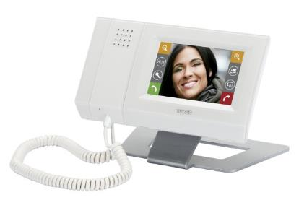City Vision is a scalable video entryphone system based on 2-wire technology. It uses LAN networks and IP technology, and as such, can be extended in terms of the range and number of devices connected. The system provides audio/video, audio-only or mixed solutions, with the possibility of integrating the standard two-wire solution with other technologies, as well as extending this using the building's existing digital infrastructures. This enables systems that are extensive and very precisely structured in terms of distances and access to be implemented, for use in large apartment complexes.

The City Vision system has specific **indoor and outdoor positions** , in accordance with the different residential environments in which it is installed. **AESIS** is the outdoor device suitable for applications with a maximum of 4 residential units; **KARALIS** and **ANTAS**, meanwhile, are outdoor positions for large-scale applications (apartment buildings, large residences, buildings for the advanced commercial sector etc.). Available in audio only or audio/video versions, these outdoor devices have been built using high-quality materials that guarantee a degree of protection (IP54) that enable this technology to withstand even the most extreme weather conditions.

GEWISS also offers a wide range of solutions for indoor positions that can be adapted to suit any request, preference or budget. Users can choose between traditional positions such as **NORA** (entryphone with handset) and **VELIA** (surface-mounted video entryphone with traditional button keys available in audio and audio/video versions and with speaker phone), or cutting-edge devices such as **SENA** and **NAXOS** and **NAXOS COMBI**: SENA is a surface or flush-mounting indoor position with soft-touch button keys and speaker phone; NAXOS, meanwhile, comes with touchscreen display, speaker phone with built-in handset and voicemail function, and can be installed as a surface-mounted or free-standing device. Finally, NAXOS COMBI is a combined panel which unites the functions of NAXOS with domotics supervision.

All the City Vision devices are distinguished by their design, blending elegance with a cutting-edge, contemporary spirit: the innovative geometries of the solutions are designed to create a refined, understated style that accentuates both the architecture of the building and the design of the furnishing elements inside it.