November 2016

LIGHTING BECOMES SUSTAINABLE

Smart[4] by GEWISS is the revolutionary, totally green lighting system for commercial and industrial contexts.

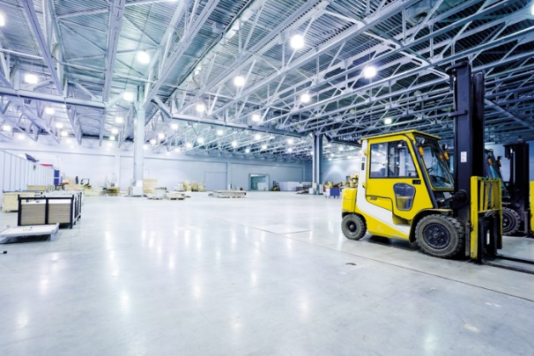In recent decades, there has been a notable increase in pollution and energy consumption. The commitments to reducing consumption and emission levels (the 20/20/20 climate and energy package passed by the European Community and laid out in Directive 2009/29/EC) relate to lighting too. The aim is to produce optimised lighting systems, with the light efficiently produced and effectively used. This encourages the use of energy-saving sources and, at the same time, favours the production and use of lighting devices that exploit the primary flux in the most efficient way possible. In other words, to produce ergonomic lighting that offers good performance and visual comfort, it's not enough just to use high-efficiency sources. The flux must be directed and shared out to create a bright environment that's compatible with the physical and psychic needs of people's sight.

In this regard, the most recent technical writings (CIE TR 205/213) focus on the qualitative aspects of indoor lighting: LED lighting cannot be evaluated solely on the basis of quantitative parameters because the visual comfort aspect plays a fundamental role in work environments. This means that average illumination and uniformity are not sufficient for defining the performance of an indoor lighting system

1. **The GEWISS Smart [4] system**

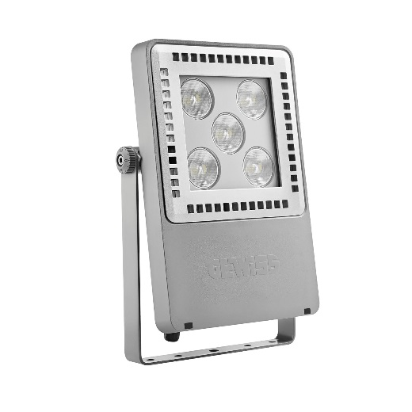To meet these needs, GEWISS has launched a range of products that take full advantage of the particular features of LED technology, ensuring excellent energy savings and optimum visual comfort. Smart[4] is multiform, rational, sustainable, extremely lightweight and versatile; it can be transformed from floodlight to ceiling light, offering different performance levels for different contexts. The practicality of the device guarantees maximum lighting performance in any area of application, from industrial to sports environments, indoor or outdoor. And that's not all. The horizontal and vertical modularity of this product combines with easy installation and maintenance, and the use of “green” construction materials (plastic and aluminium).

Smart[4] is innovative technology enclosed in a minimalist, sharp, linear style with a definite Italian feel. The design aim, in fact, was to emphasise the typical characteristics of LED lamps: lightweight, small, practical and robust. These features were transferred to the end product, providing it with unequalled performance levels.

The use of power LEDs with high colour performance, high efficiency optical systems (high bays and lenses) and the availability of multiple configurations make Smart[4] an ideal instrument for minimising costs (for operation and maintenance) and maximising lighting performance.

1. **Designed for upgrades**

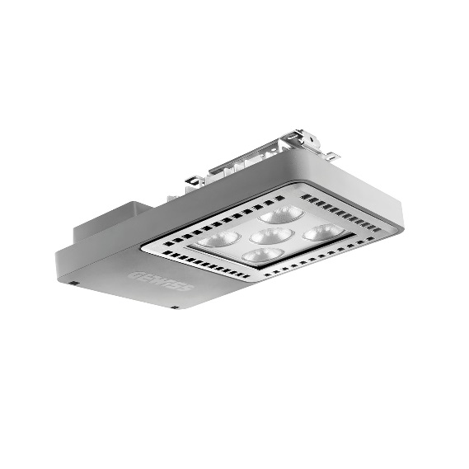Recent statistics show that most lighting systems in industrial and commercial environments are based on technologies and regulations that are now obsolete. In the case of existing systems though, the current technologies can only be adopted if the hardware is intrinsically flexible. Obtaining a good upgrade means using products that adapt to the pre-existing situation.

The distance (longitudinal and transversal) between the lighting devices can't usually be modified without reconstructing the supply lines and/or junctions. The preservation of the existing geometries necessarily requires devices with:

* a series of photometric curves (e.g. with rotational symmetry - with different beam widths - asymmetric and elliptic);
* several nominal fluxes, that can be selected according to the illuminations and uniformity you want to produce on the surfaces;
* anti-glare devices for installation at lower heights.

The Smart[4] system can take six different optics: four with rotational symmetry (100°, 60°, 30°, 10°), one elliptic (60°x120°), and one asymmetric (52°). In the various types, the light flux ranges from 2800 lumen to 25,500 lumen (31÷285W, losses included). From the mechanical viewpoint, this system can be held in place in a number of ways: in the plate/spring version, the body is installed after the plate has been fixed, pressing slightly to trigger the steel spring; the quick watertight connector is then used to connect the device to the mains supply, without opening the power supply compartment.

All this means a complete lighting system, not just a device.

After all, Smart[4] was designed and developed as a system for making upgrades truly sustainable, so that lighting systems could be adapted in a quick, easy and cost-effective manner.

1. **The range**

The Smart[4] range has two lines:

* **Smart[4] LB|HB**: ceiling-mounting luminaire: technopolymer frame; die-cast aluminium dissipator with a low copper content; galvanised iron fixing plate; fixing spring in pre-stressed steel wire; IP66 and IK08 degree of protection; Glow Wire 650°/850°.
* **Smart[4] FL**: floodlight: technopolymer frame; dissipator, glass-holder and bracket coupling in die-cast aluminium with an adjustable low copper content; tempered glass (4mm thick); galvanised iron fixing plate; fixing spring in pre-stressed steel wire; IP66 and IK10 degree of protection; Glow Wire 850°.

The production processes and materials used all meet the most recent environmental sustainability requisites (rationalisation of resources and minimised environmental impact). The entire range is purposely designed and developed to ensure simplified installation and easy retrofit on existing systems.

1. **Conclusions**

The use of Smart[4] meets the most advanced needs in the field of industrial and commercial lighting for indoors and outdoors.

It guarantees:

1. Energy savings of between 50 and 80%
2. Lighting quality and visual comfort
3. Easy, quick replacement of devices installed in existing systems (upgrade)
4. Notable savings as no routine maintenance is needed
5. Investment pay-back in 18-36 months
6. Energy efficiency incentives
7. Bank-financed investment

An immediate return on investment plus quick, easy implementation: in a nutshell, these are the characteristics that make Smart[4] a truly unique product.