November 2017

CUTTING-EDGE TECHNOLOGY AND TRADITION

Chorus system domotics technologies are at the heart of the ancient Santa Caterina monastery, which is now the Relais Nun.

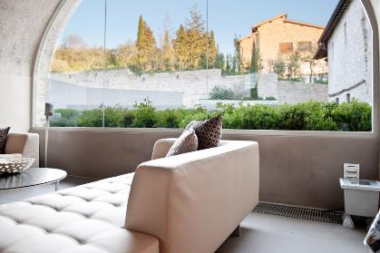The Relais Nun is located at the heart of Assisi in the highest part of the historic centre, with views across the Rocca Maggiore and Minore, and over Monte Subasio. Following a careful renovation project, the ancient monastery of Santa Caterina, which dates back to 1275, has been transformed into a relais hotel, featuring 18 suites and the Nun Spa Museum wellness centre. The building project focused on the preservation and enhancement of the original characteristics of the building, integrating these with modern hospitality technologies. The solutions implemented throughout are taken from the GEWISS Chorus range of domotics systems, which include intelligent building control devices and energy protection and distribution systems.

The adoption of domotics technology for the management of the facility **has guaranteed the energy-saving and safety solutions and comfort** that traditional systems can only provide in part. In this case, the automation solutions offered by this domotics system have enabled all of the various parameters that significantly affect the well-being of guests and the quality of their stay at the Relais Nun to be managed and controlled (**lights, background functions, climate, air quality**). In addition, the aesthetics of the spaces were taken into careful consideration, with natural resources safeguarded and respected.

The ability to manage the air conditioning in summer and winter through an **independent timed thermostat system with multi-zonal temperature control** has also enabled significant reductions in energy consumption and relative costs. Indeed, the Chorus system enables users to set different temperatures in different areas of a building, or even to vary temperatures on individual floors, in order to reduce wasted energy. In addition to provided a function for heating, enabling this to be turned on or off at pre-set times, this domotic system can also provide more flexible temperature control across three levels, which can be set in accordance with individual requirements. Within a 24-hour period, users can set three different temperatures for different times of the day. Moreover, with the timed thermostat, it is possible to heat just a few rooms, automatically varying the temperature between them.

Meanwhile, the adoption of **presence detection and light-sensitive sensors** for detecting natural light and **dimmers for** regulating the light intensity enable energy consumption to be rationalised and reduced, in accordance with the amount of light in the building.

The aesthetic harmony of this ancient building has been respected in full, with **Chorus One and Lux** plates fitted for lighting and shutter commands, blending modern flair and the elegance of tradition. The Chorus domotic system has enabled the ancient and modern to coexist, with cutting-edge technology and classicism side by side.