November 2016

EMERGENCY SYSTEMS FOR BUILDING AUTOMATION

The STARTEC EIB range from GEWISS offers advanced solutions for creating centralised emergency systems with the KNX communication protocol.

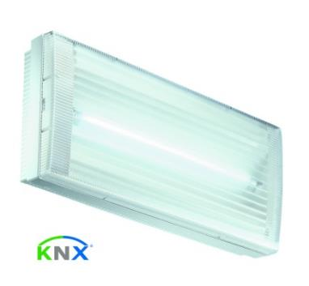There is a need to create centralised emergency systems that communicate with the domotic system and are integrated with it; that need is now met by the STARTEC EIB range from GEWISS - a complete range of emergency devices that can be integrated in building automation systems.

The luminaires of the STARTEC EIB range are unique: GEWISS is, in fact, the only company that offers autonomous emergency luminaires that communicate via the BUS using the KNX communication protocol.

The STARTEC EIB range includes autonomous luminaires for centralised management systems for surface-mounting, ceiling-mounting, double-sided use and flush-mounting. They are available with an IP40 or IP65 degree of protection, and an autonomy level of 1 or 3 hours. To guarantee the maximum reliability and lifespan, the luminaires for signal lighting are available not only in the conventional fluorescent version but also with high-efficiency LED technology.

The double-sided luminaires with LED technology are available in two different versions: conventional, or with an additional side spotlight. The latter has a spherical joint so it can make a complete rotation, ensuring the utmost freedom when directing the light beam.

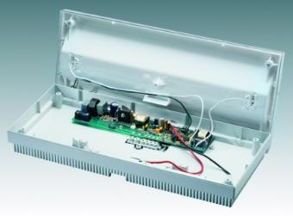All the luminaires are equipped with an electronic card managed by two microprocessors. The first manages all the functions of the luminaire: it guarantees the accumulator charge and the switch-on of the fluorescent conduit in emergency situations, as well as performing regular tests and indicating the outcome via the multi-colour LED on the luminaire itself. The second, on the other hand, manages communication with the system, sending and receiving all the information needed for correct system management. Communication is via a specific signal cable, using the protocol in compliance with the EIB Standard.

The use of the KNX world Standard allows the emergency system to be directly integrated in the building automation. It is not necessary to create a new domotic system just to manage the emergency lighting; the central system is sufficient once its functions have been expanded.

The programming of the lamp and battery tests is managed directly from the system supervisor, using the software. After being configured with the ETS software (EIB Tool Software), the luminaires transmit the test outcome and their operating status directly on the BUS, hence speeding up maintenance operations.

Thanks to the libraries made available by the various manufacturers, the ETS software can be used to design and create smart systems based on the KNX protocol.