November 2016

P-COMFORT, SOLUTIONS FOR ENERGY EFFICIENCY

GEWISS P-COMFORT is the device that encourages greater awareness of system energy consumption and automatically manages energy overloads.

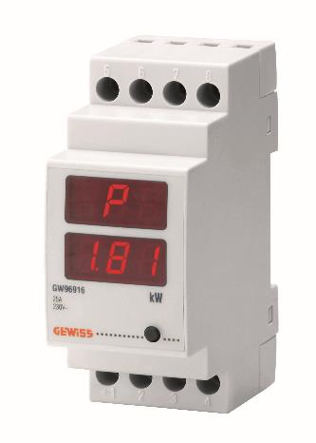P-Comfort is a device that can be installed in the conventional domestic enclosure for the smart management of the electrical system power.

If several domestic appliances are switched on at the same time, **P-COMFORT activates a buzzer and an optic warning signal to inform the user that the energy consumption limit is being exceeded**. In this way, the user only has to deactivate one of the appliances to bring the consumption level back below the permitted threshold.

If the overload continues however, P-COMFORT does not cut off the power supply to the entire home but only to the non-priority appliances (as chosen by the user himself), autonomously reactivating them after a pre-fixed time gap. For example, if the electric loads of the bathroom are set as non-priority, and the oven and hair-dryer are subsequently used at the same time (and there is no direct intervention), only the current to the hair-dryer will be cut off; the oven and other kitchen appliances will carry on working as usual.

This means everything will continue working in the normal way, and the home will not be plunged into darkness. In addition, the display on the device lets you **view and keep under control the level of power absorbed by the home at any time**. This means a greater awareness of the energy consumption levels in the home, **encouraging a more rational use of energy to avoid useless waste**.

**Caption: the GEWISS P-Comfort device controls consumption levels and disconnects the non-priority appliance if the contractual threshold is exceeded. It prevents blackouts.**